**AIM : Creating two virtual machines on the Azure platform and connecting those virtual instances to each other**

**Step 1:** After successfully logging into the Azure platform, go to [http://portal.azure.com/.](http://portal.azure.com/) In the left top corner click on **Create a resource**.

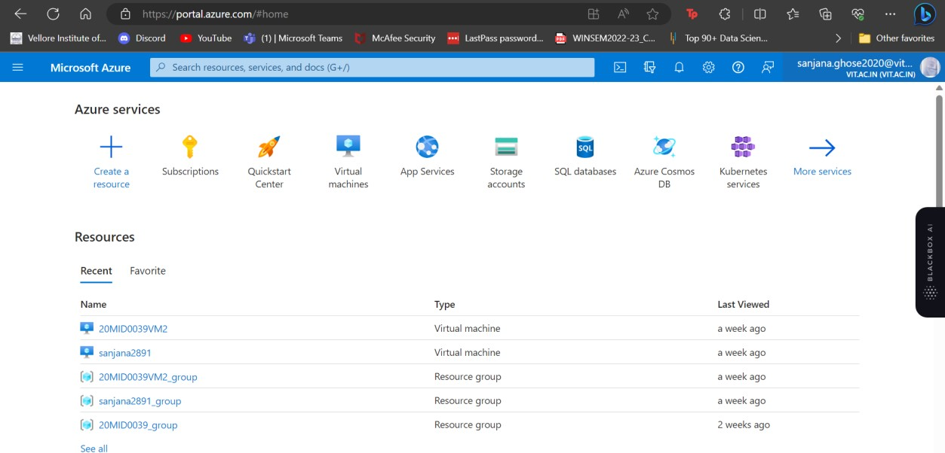

**Step 2:** In the left top corner click on **Create** under the option of Virtual machine.

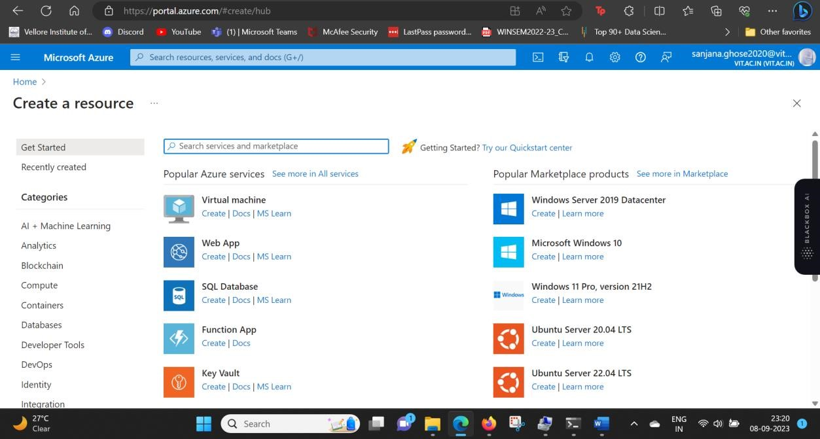

**Step 3:** Name your virtual machine that should be your **RegisterNumber_VM** and then give the User name that should be **Student-Name_VM (without spaces).**

**Step 4:** Name your virtual machine that should be your **RegisterNumber_VM** and then give the User name that should be **Student-Name_VM (without spaces).** Click on **Next::Disks** and thenClick on **Next::Networking.**

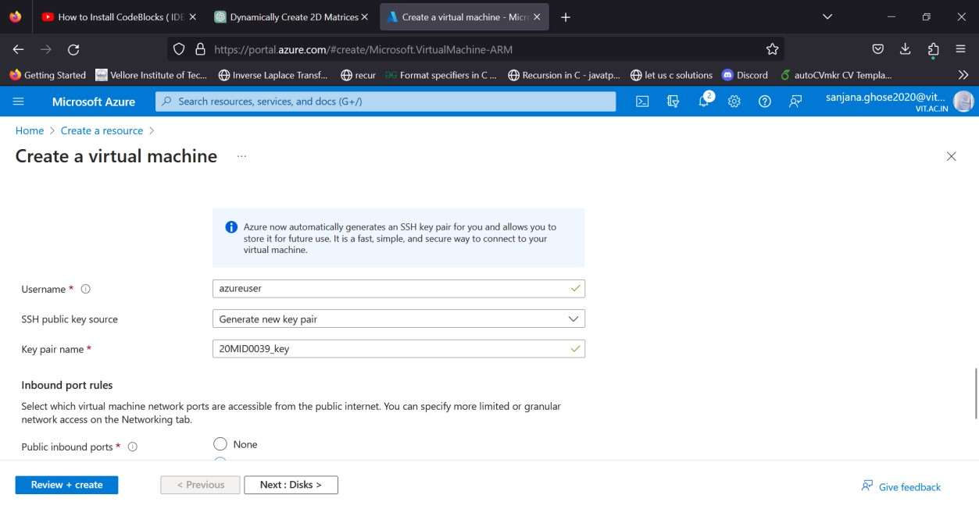

**5:** Ensure that the Public IP is filled with some values (preferably your VMName-ip) and it should not be null. Finally, click on **Review + Create**

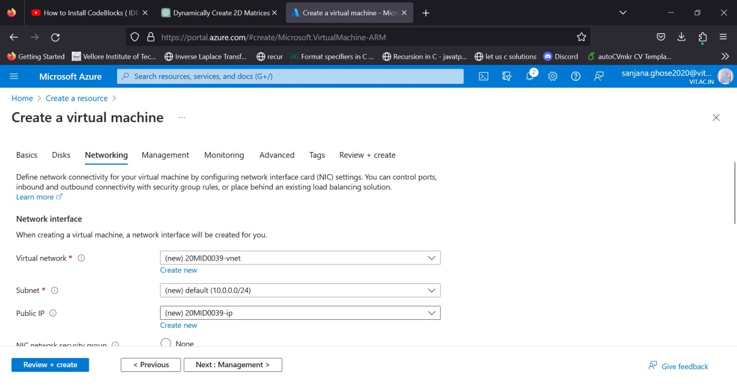

**Step 6:** The pop-up box will be generated, where click the **Download private key and create the resource**

After that one key fille will be downloaded in your physical machine (20212VM1_key.pem) and the deployment of virtual machine in progress.

**Step**

**Step 7:** After the deployment is completed, get a window like the following, in which click on **Go to resource**. After that, click on **Overview.**

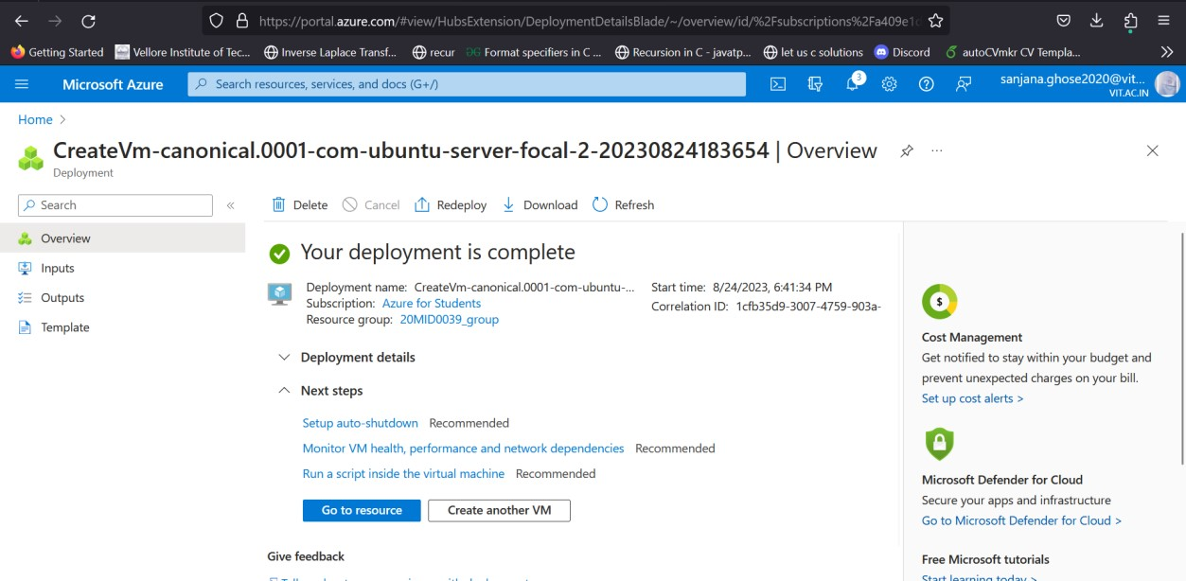

**8:** Click on **Networking** and click on **Add inbound port rule**.



**Step 9:** Select ICMP (mandatory), give any name under the Name field (optional) and Click **Add**.

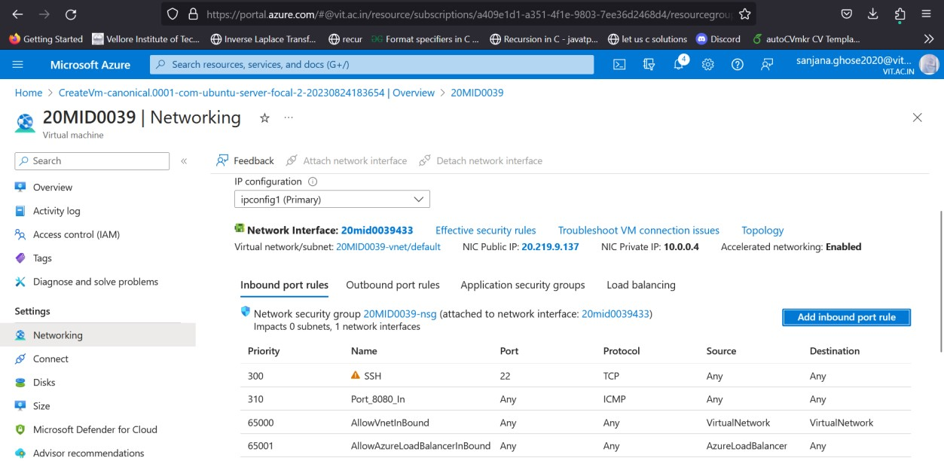click on **Add outbound port rule**.



**Step 10:** Select ICMP (mandatory), give any name under the Name field (optional) and Click **Add**.

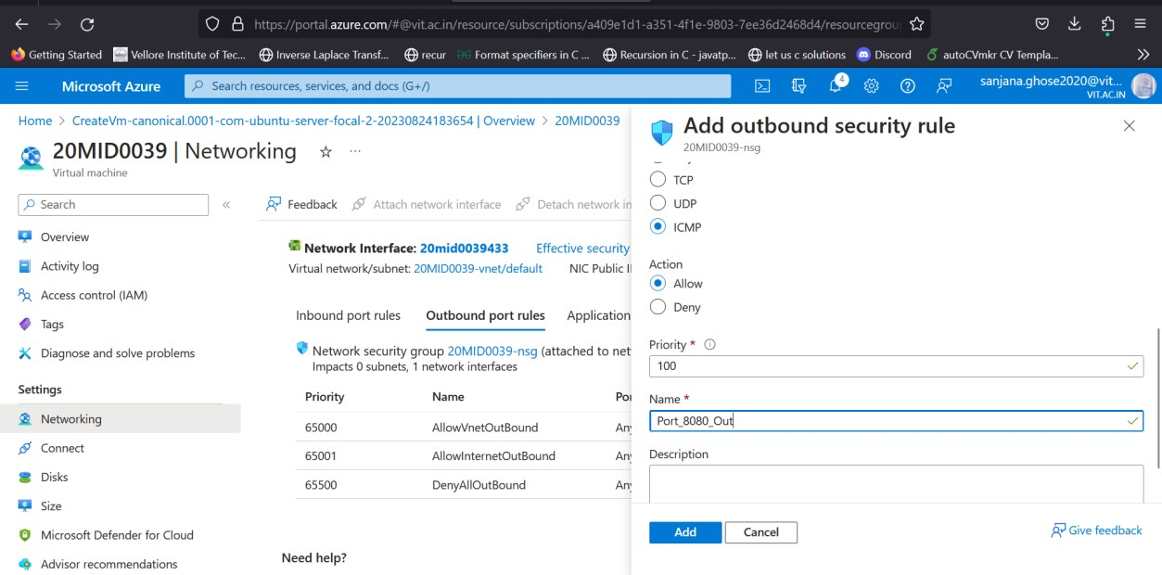

Click on Overview. Ensure that public IP should be assigned with some IP address.

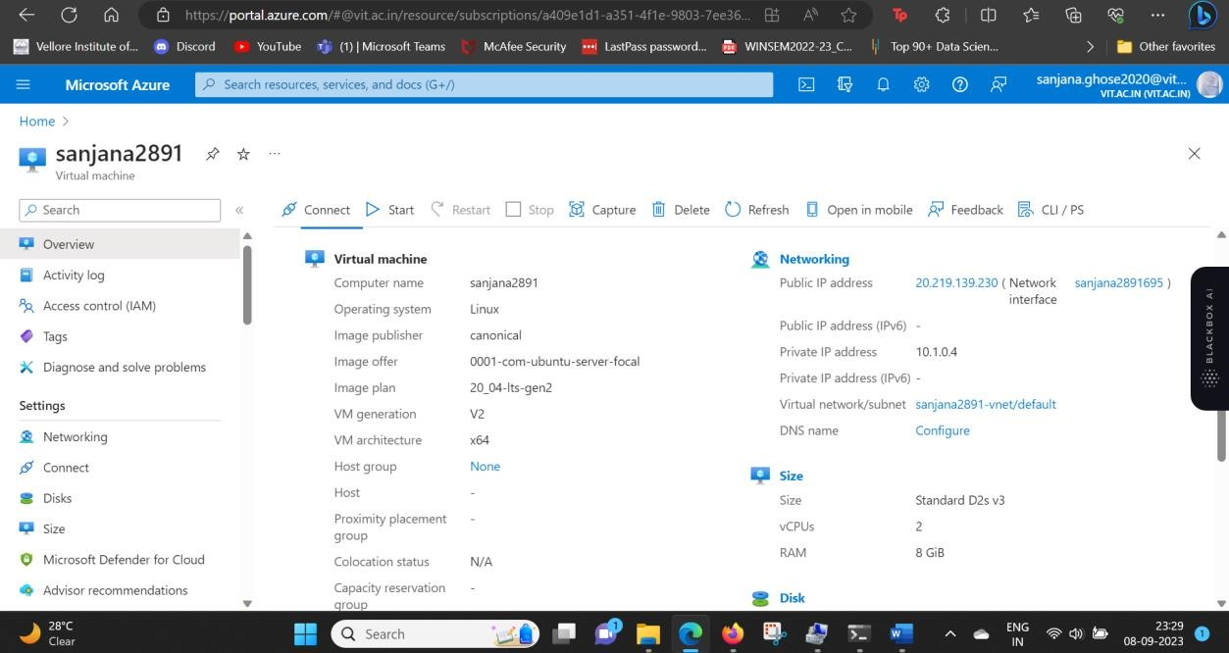

**Step 12:** Click on **Connect**. Click on **Select** under **Native SSH.**

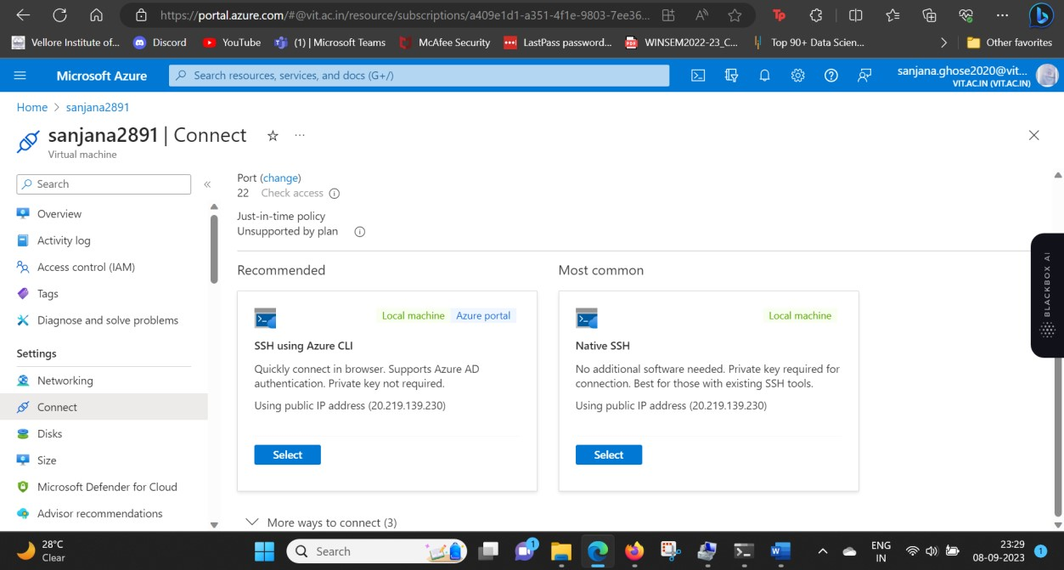

Copy the command that is present under **Copy and execute SSH Command.**

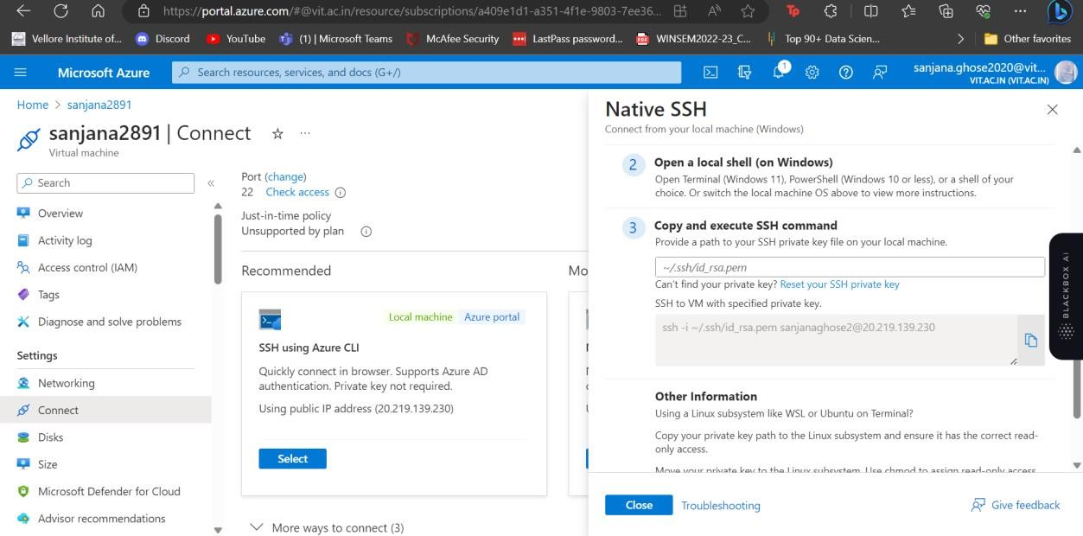

**Step 13:** Open your physical machine command prompt and type the command.

For example, Configure the copied command

(**ssh -i ~/.ssh/id_rsa.pem ArunVM_1@4.213.2.106**)

Replace **~/.ssh/id_rsa.pem** with thelocation of the downloaded private key field **C:\Users\arun6\Downloads\20212VM1_key.pem.**

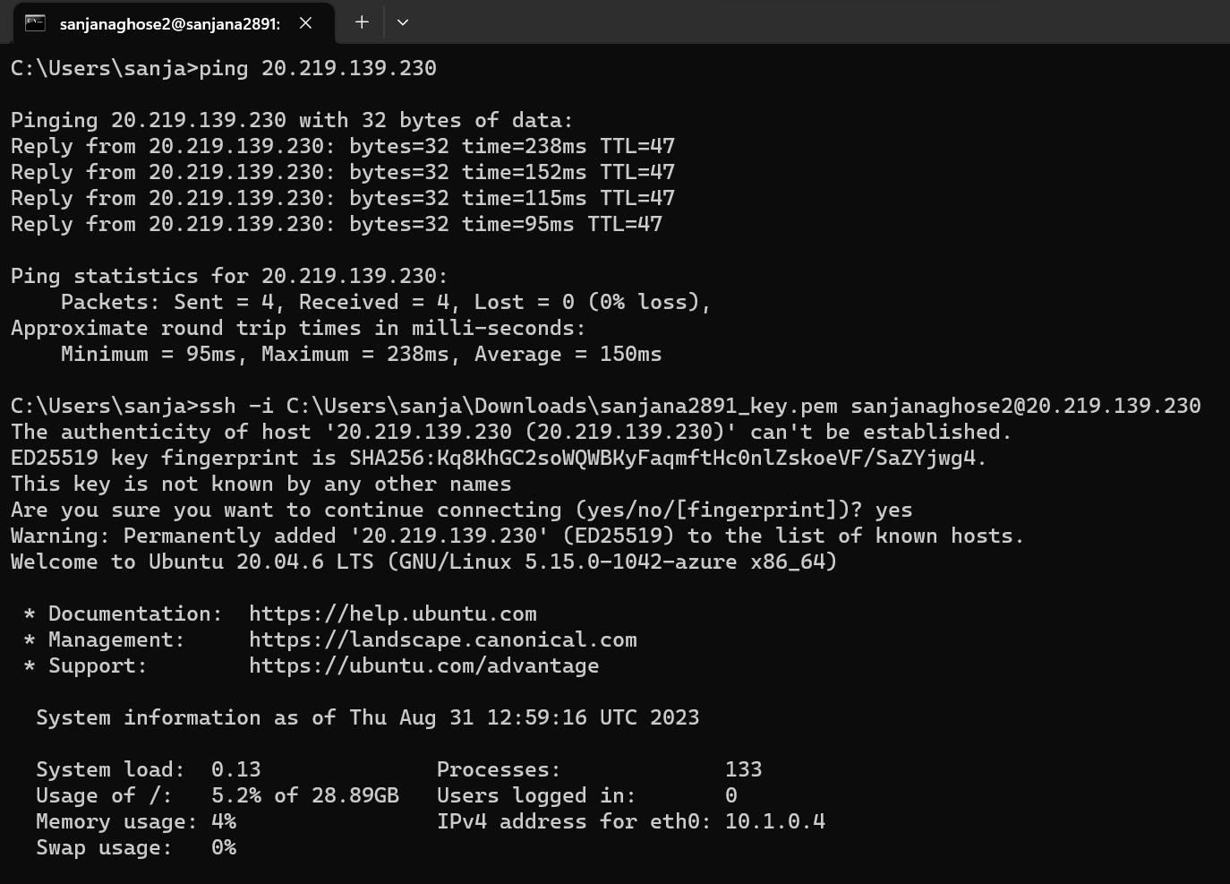

**Step 14:** Then you can access the created VM command from your physical device.

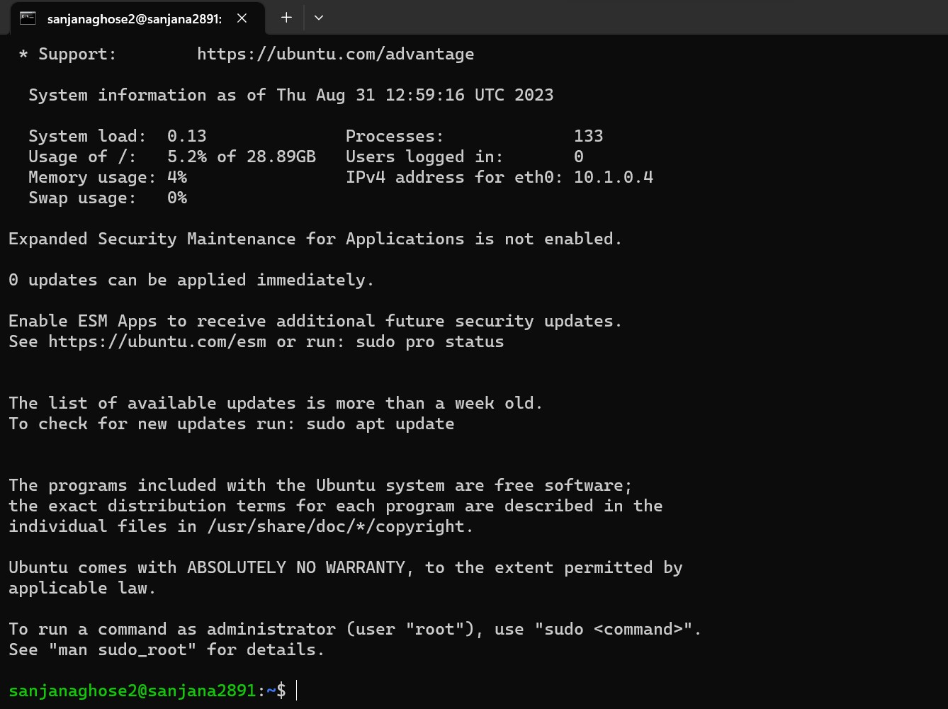

**Step 15:** Create a directory in that.

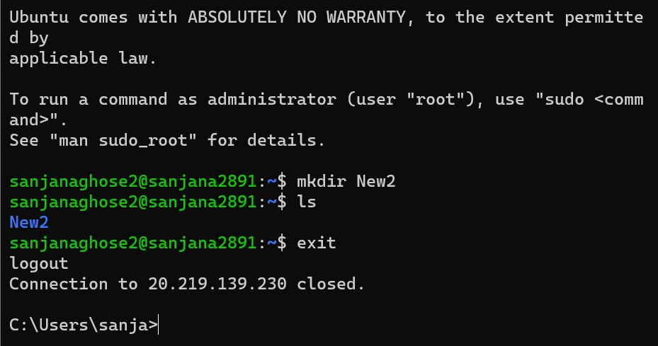

**Step 16:** Then you can copy a file from a physical device to a virtual device using the following command.

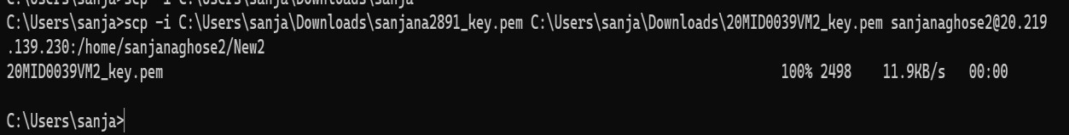

**Format:**

# scp -i path_of_private_key_file file_name-want-to-copy

***UserName@PublicIP address_of_virtual_Instance***

***:/home/UserName/created folder***

**Step 17:** Create another machine using above steps 1 to 14.

**Step 18**: Open VM1 from the physical device and connect the second VM2 using the ping command.

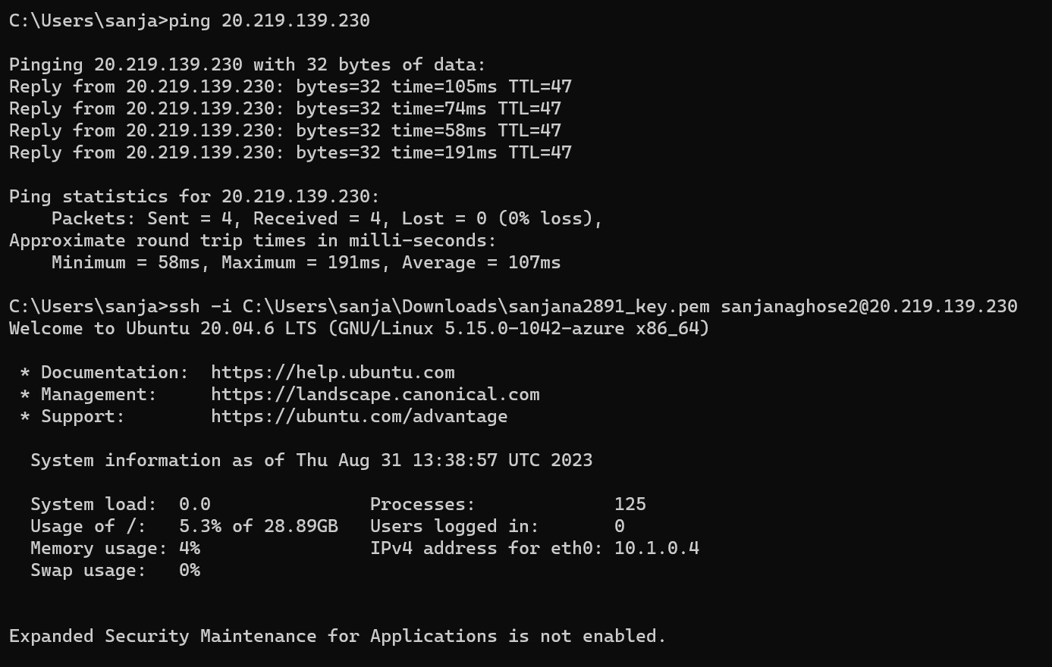

**Note: To do this follow Step. 14 from the VM1 command prompt.**

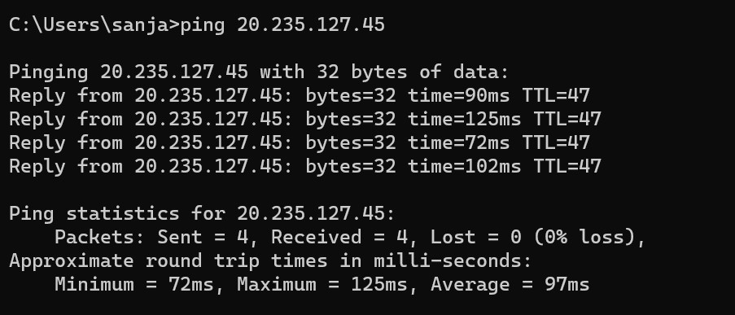

**Step 19:** Open VM2 from the physical device and connect the second VM1 using the ping command.

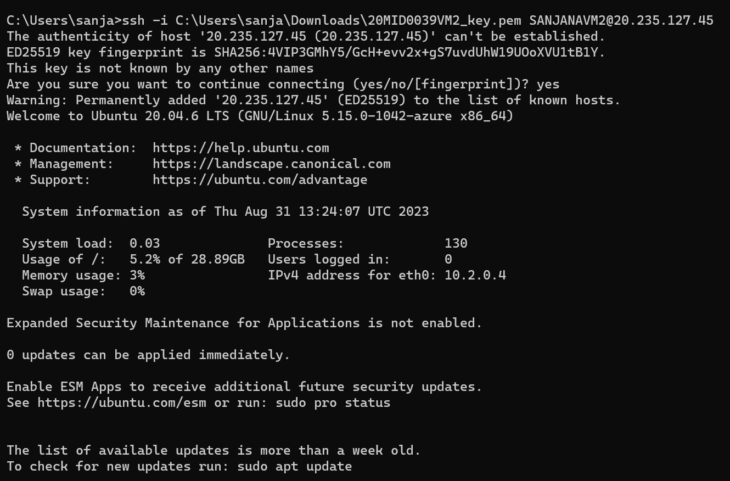

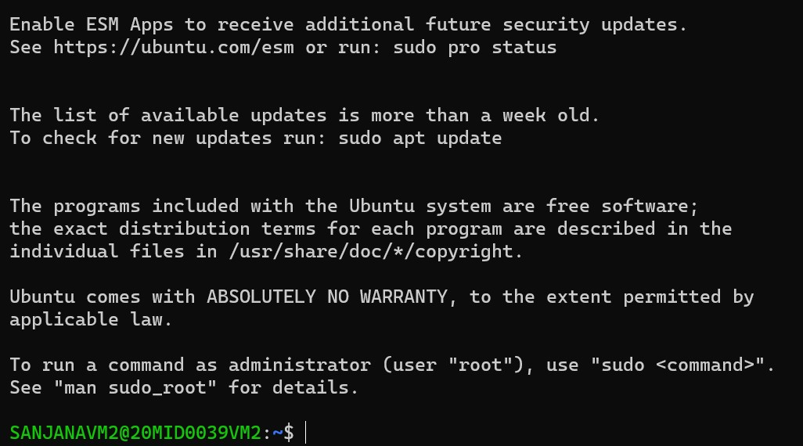

**Step 20:** Also, you can open the VM2 command prompt from the VM1 command prompt.

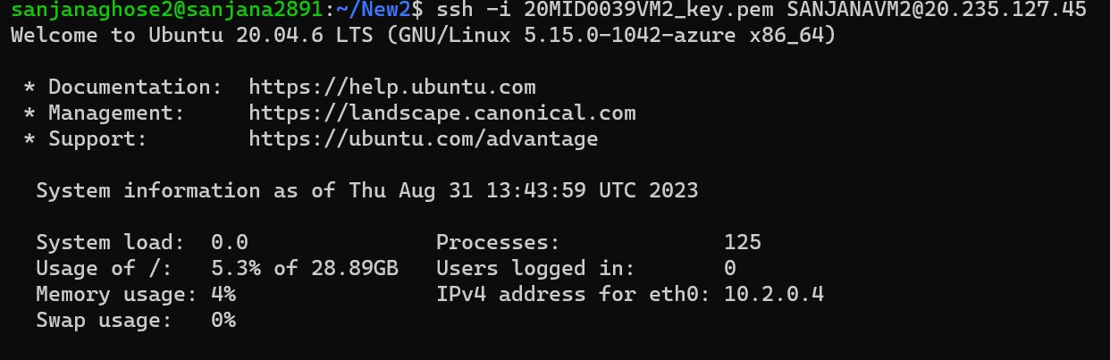

**Step 21:** Create a folder in VM2 from the VM1 command prompt.

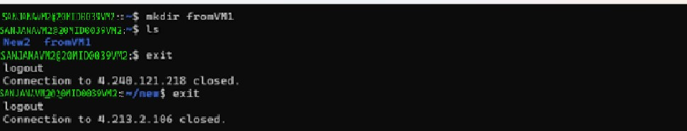

# Creation of Word Press Site using Azure Portal

**Step 1:** To start creating the WordPress site, browse to <https://portal.azure.com/#create/WordPress.WordPress>

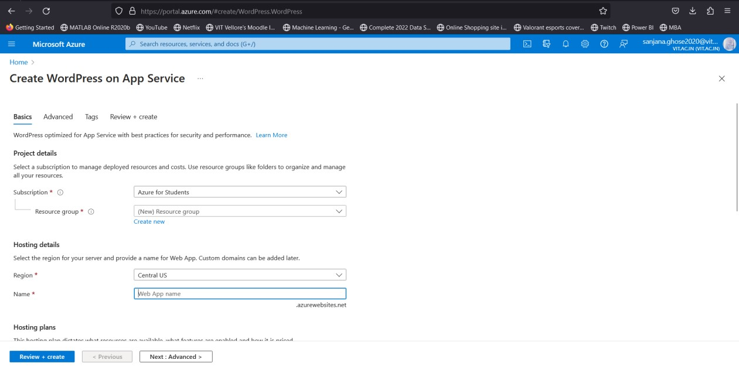

**Step 2:** In the **Basics** tab, under **Project details**, make sure the correct subscription is selected. Select **Create new** resource group and type your **RegisterNumber_wordPress** and for the name type any combination of your **Name. (Make sure that it is available)**

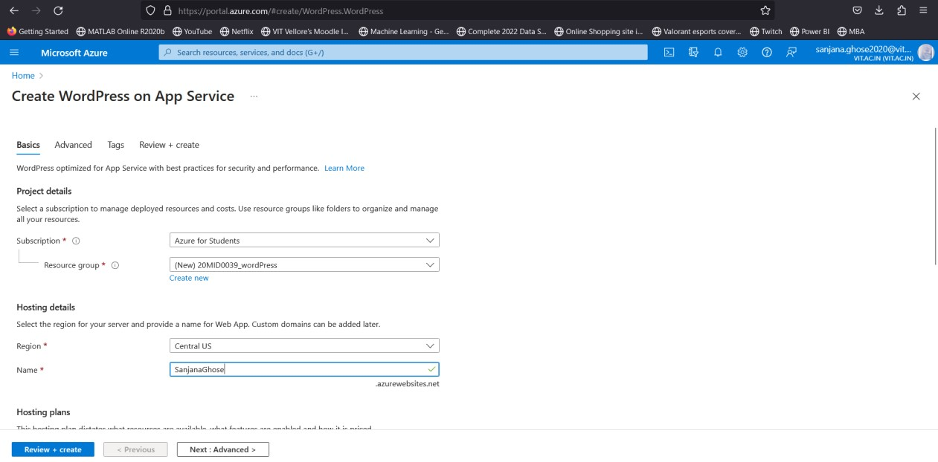

**Step 3:** Under **WordPress setup**, choose your preferred **Site Language**, then type an **Admin Email**, **Admin Username**, and **Admin Password**. The **Admin Email** is used for WordPress administrative sign-in only. Clear the **Enable multisite** checkbox.

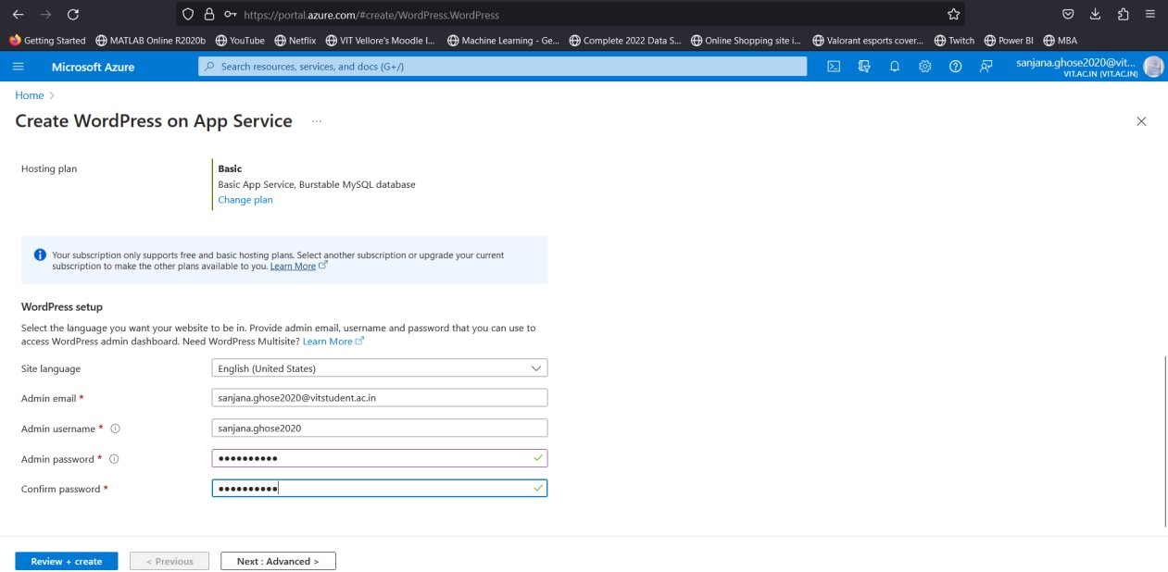

**Step 4:** Select the **Review + Create** tab. After validation runs, select the **Create** button at the bottom of the page to create the WordPress site.

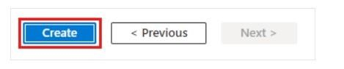

## You will window like once click create

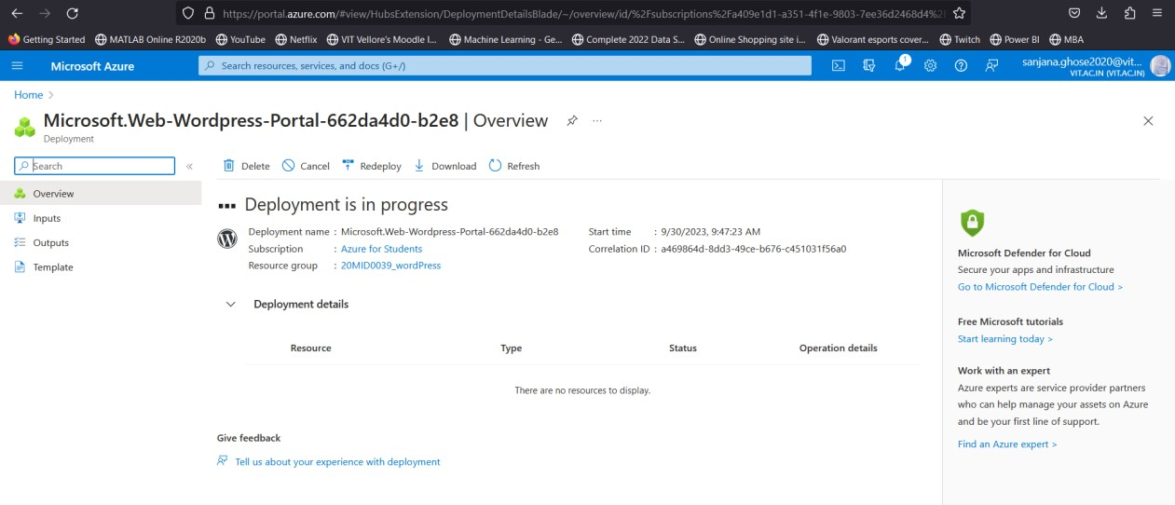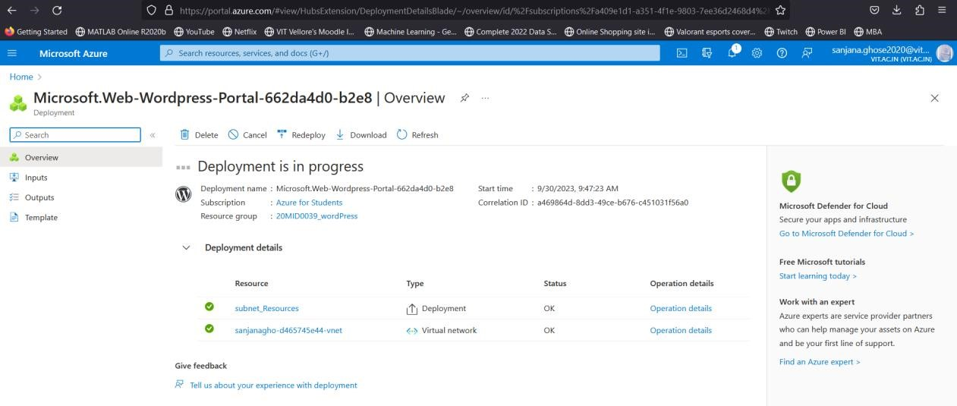

**Step 5:** Once completed you will get will window like the following in which click on **Go to resources**.

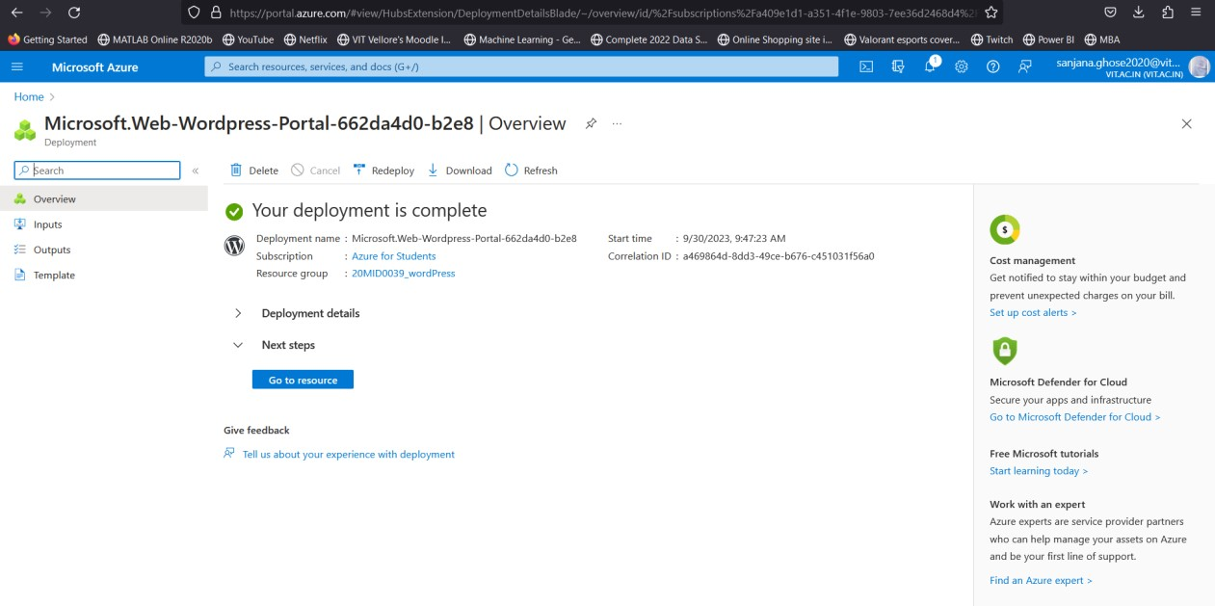

**Step 6:** Browse to your site URL and verify the app is running properly. The site may take a few minutes to load. If you receive an error, allow a few more minutes then refresh the browser.

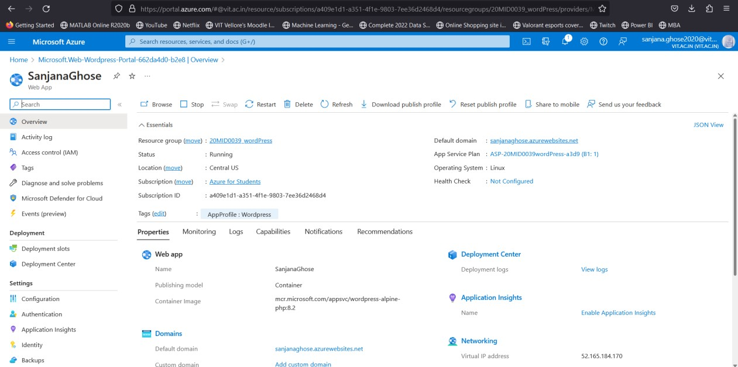

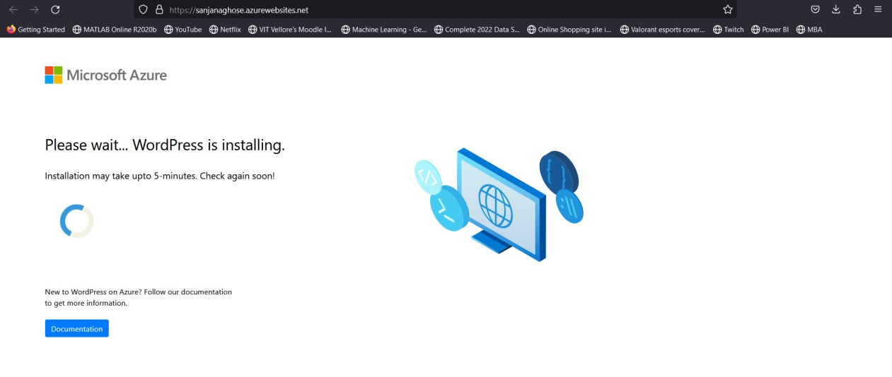

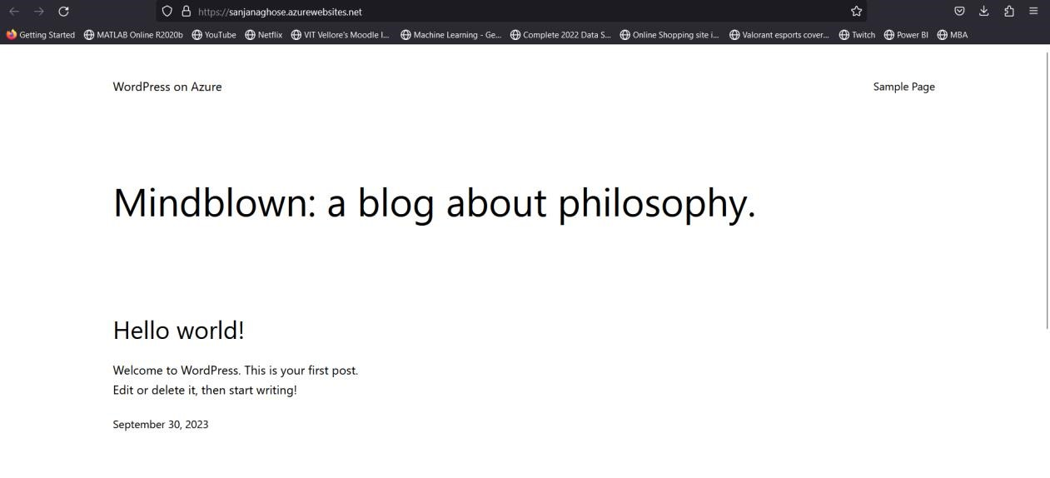

## **Step 7:** Click on the Sample Page and Click on Edit Page Give your details like Name, Reg.No, Dept, Course you are studying, etc.,

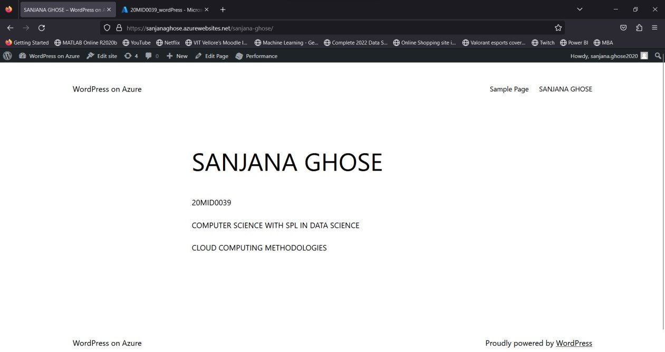

**Step 8:** To access the WordPress Admin page, browse to /wp-admin and use the credentials you created in the [WordPress setup s](https://learn.microsoft.com/en-us/azure/app-service/quickstart-wordpress#wordpress-setup)tep.

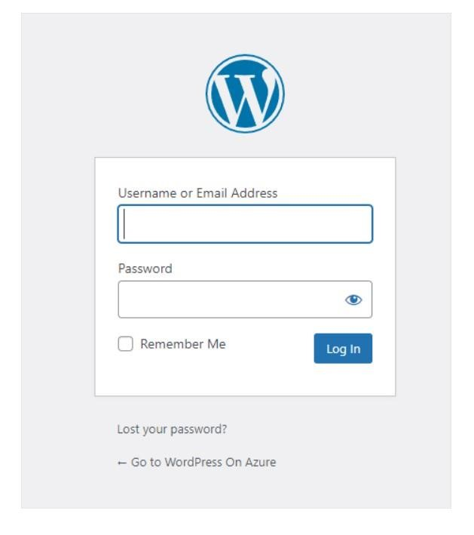

**Step 9: Then you can access your word press dashboard.**

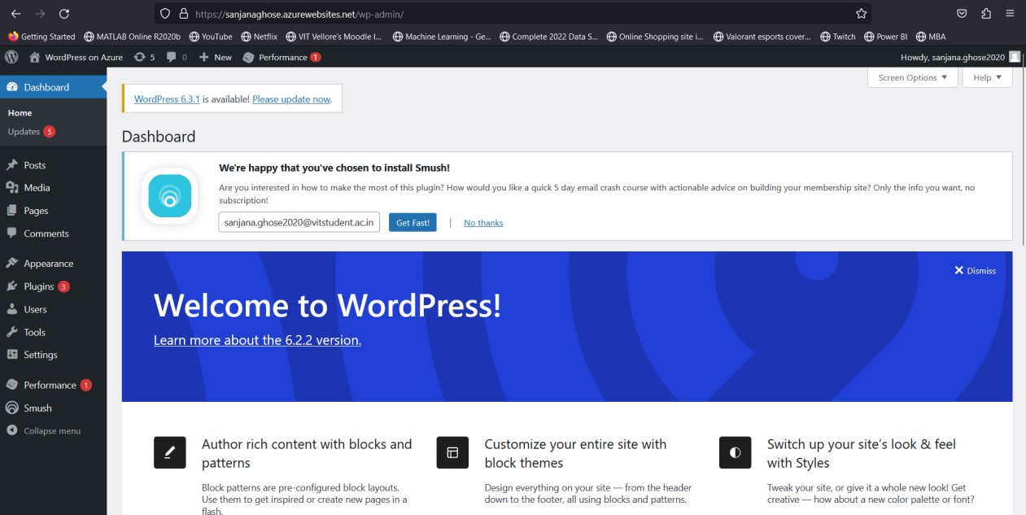

**Step 10:** Turn off your WordPress application that you created in Azure and Check whether this page is running or not.

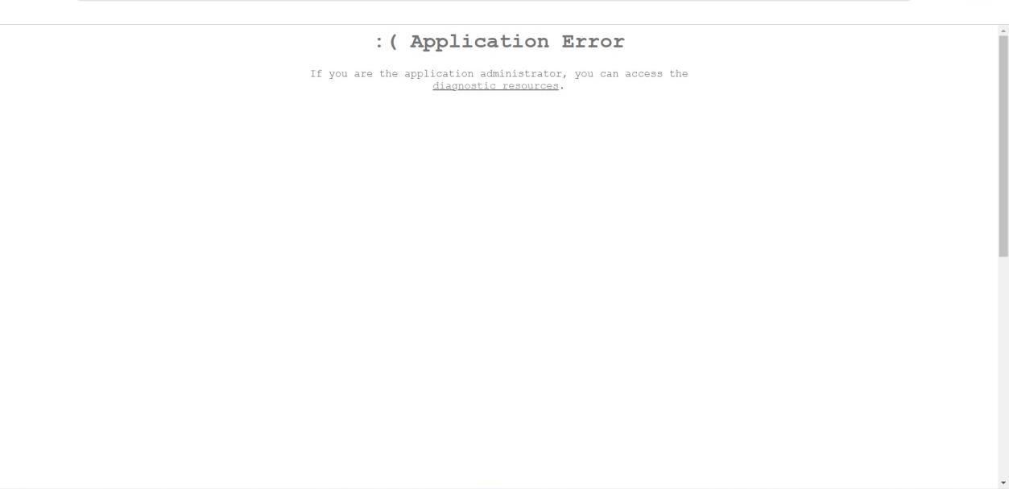

**Step 11:** Turn on your WordPress application that you created in Azure and Check whether this page is running or not.



**AIM PART 1- Create and Deploy a Web application on Azure platform**

# Section I : Create simple application

**Step 1:** Download [**Node.js** and **npm** f](https://nodejs.org/)rom the following link and install. Run the command

[**(**https://nodejs.org/en )](https://nodejs.org/en)

***node --version*** to verify that Node.js is installed.

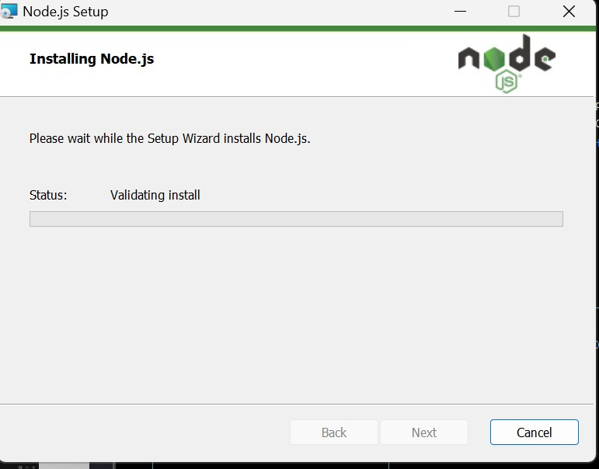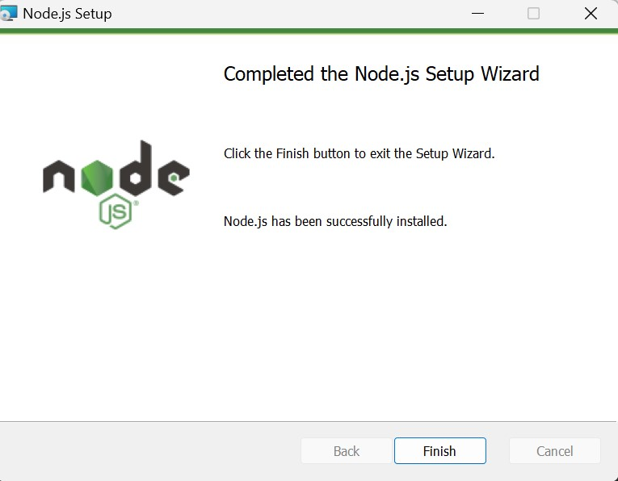

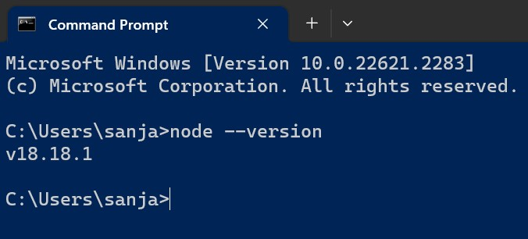

**Step 2:** Download [**Visual Studio Code** f](https://code.visualstudio.com/)rom the following link and install in your machine.

<https://code.visualstudio.com/>

**Step 3:** After installing[Visual Studio Code**,**](https://code.visualstudio.com/) add [**Azure App Service extension**.](https://marketplace.visualstudio.com/items?itemName=ms-azuretools.vscode-azureappservice)

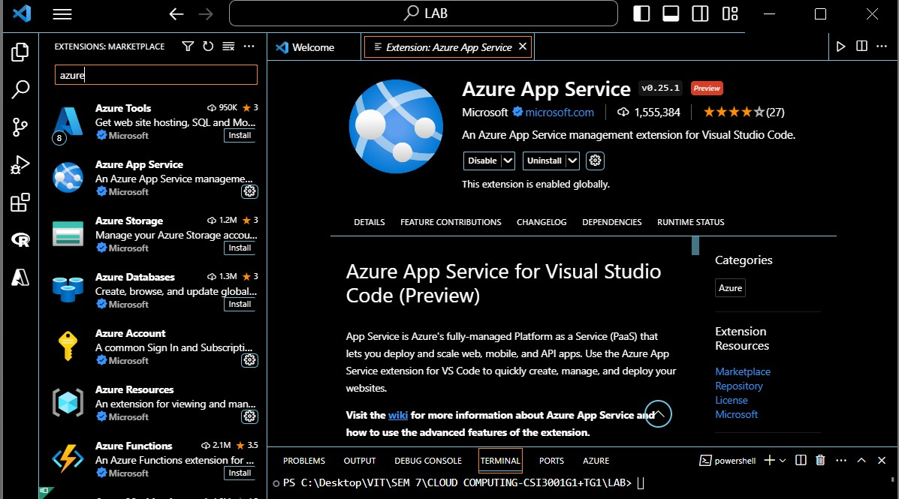

**Step 4:** Create a working directory for saving the project in your machine and open that folder.(CLOUD_SANJANA_20MID0039)

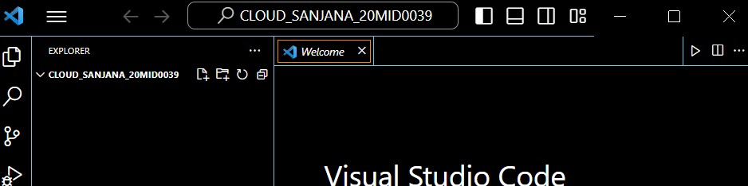

**Step 5:** Click on **Terminal** **New Terminal** that shows your working directory what you have created in the last step.

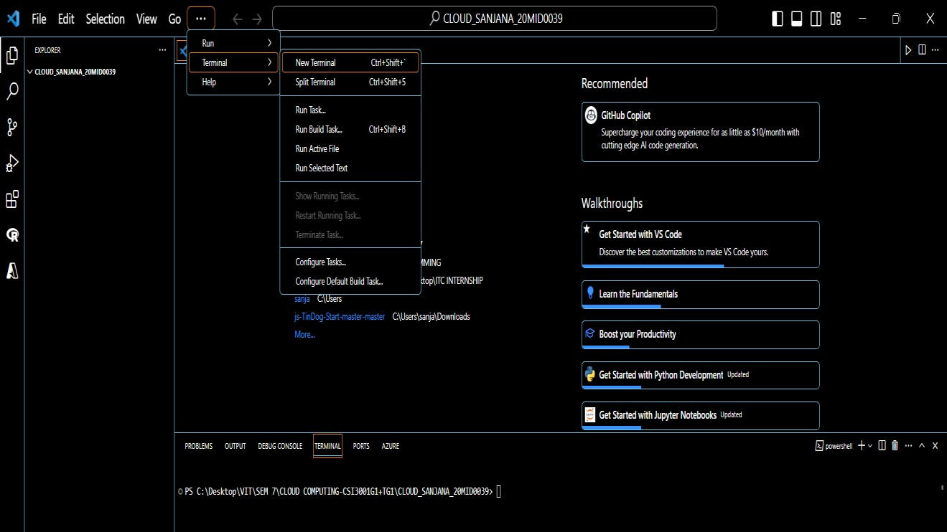

**Step 6:** Create a Node.js application using the [**Express Generator,**](https://expressjs.com/starter/generator.html) which is installed by default with Node.js and NPM. Type the following command in the terminal.

npm install -g express-generator npx express-generator myExpressApp --view ejs

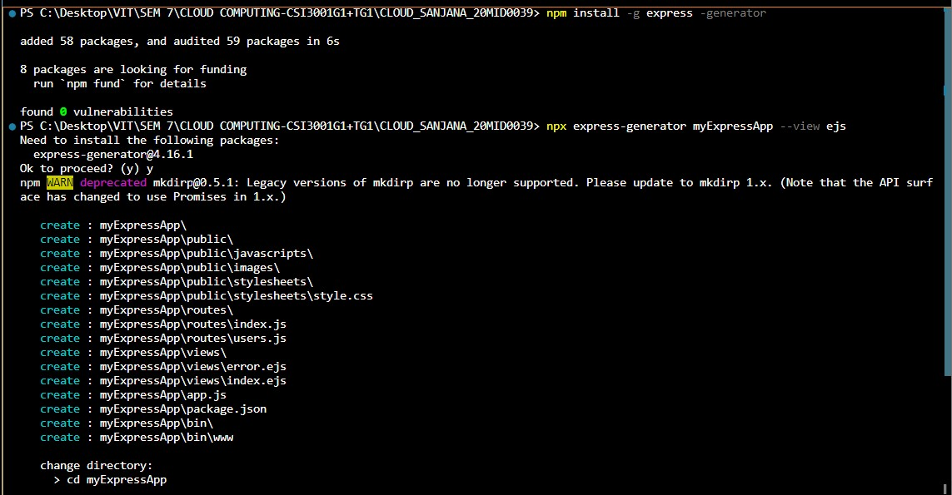

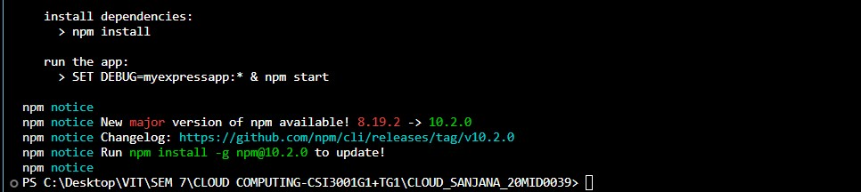

**Step 7:** Change to the application's diretory and install the NPM packages using the following command

**cd myExpressApp npm install**

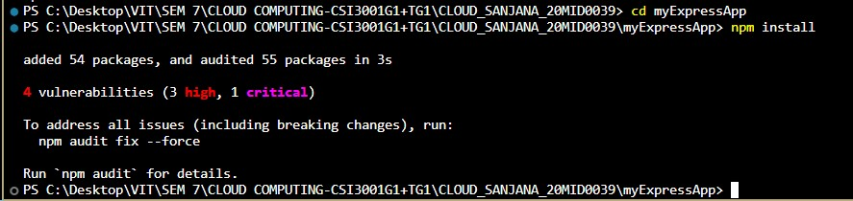

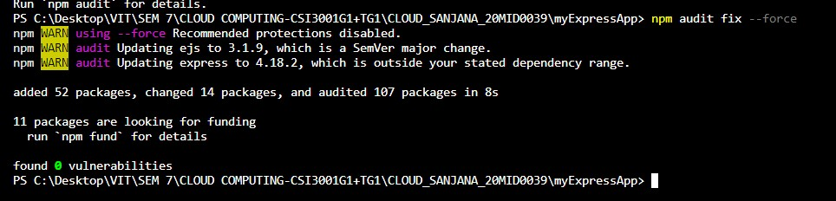

**Step 8:** Start the development server with debug information using the following comments.

**SET DEBUG=myexpressapp:\***

**npm start**

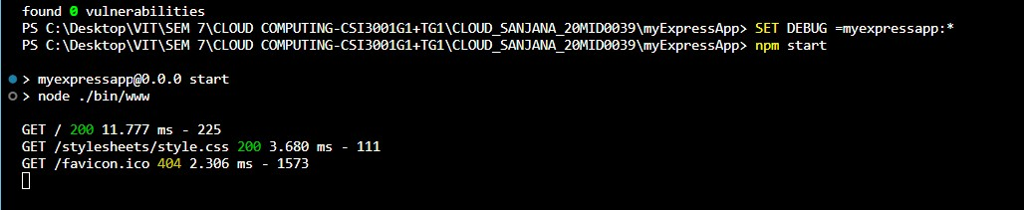

**Step 9:** Open the index.js file from the following location and give your details like Name and register number.

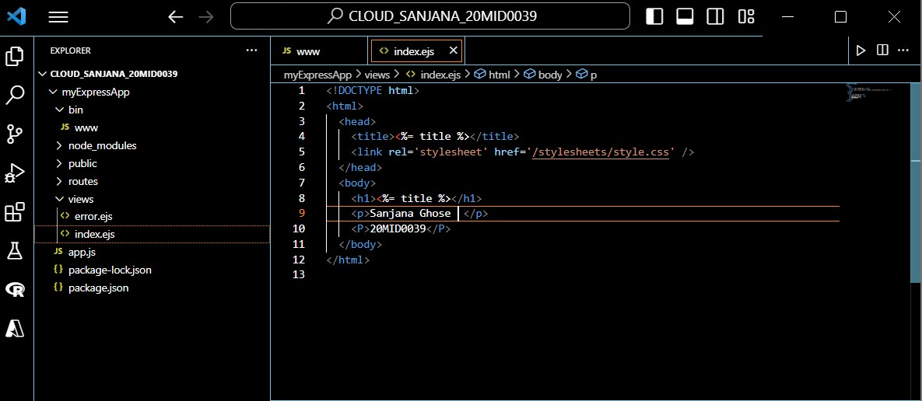

**Step 10:** Go to browser, navigate to http://localhost:3000. You should see something like this:

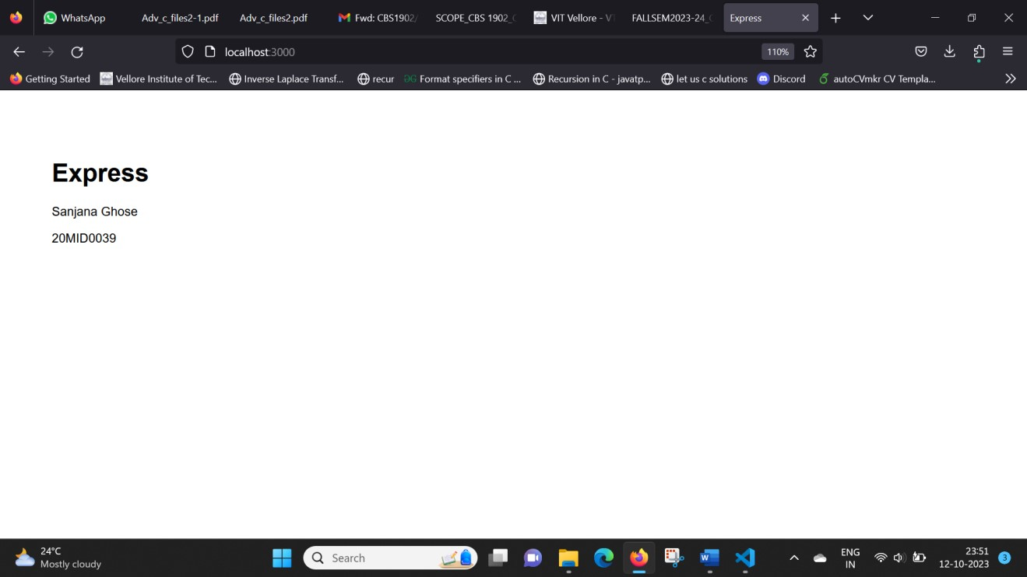

# Section II: Deploy to Azure

**Step 11:** In the terminal, ensure you're in the *myExpressApp* directory.

**Step 12:** In Visual Studio Code, in the [Activity Bar,](https://code.visualstudio.com/docs/getstarted/userinterface) select the **Azure** logo. In Visual Studio Code, you should see your Azure email address in the Status Bar and your subscription in the **AZURE APP SERVICE** explorer.

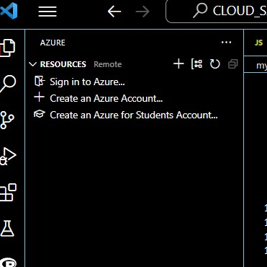

**Step 13:** Right-click on App Services and select **Create new Web App.**

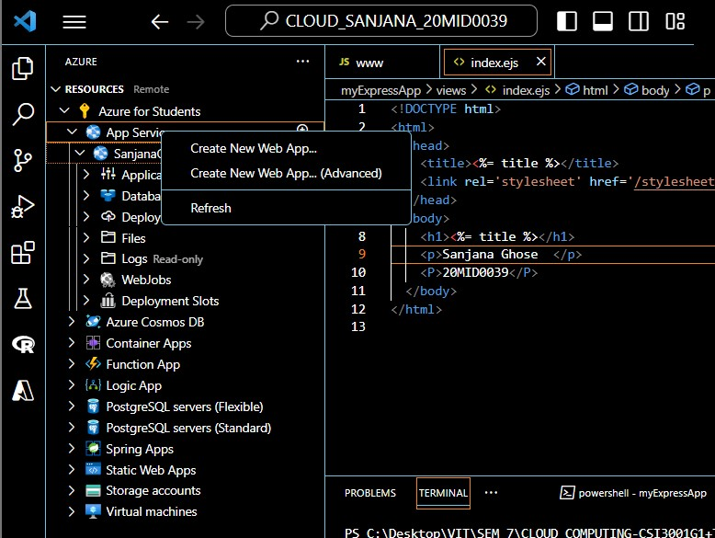

**Step 14:** Type a globally unique name for your web app and press **Enter**. The name must be unique across all of Azure and use only alphanumeric characters ('A-Z', 'az', and '0-9') and hyphens ('-').

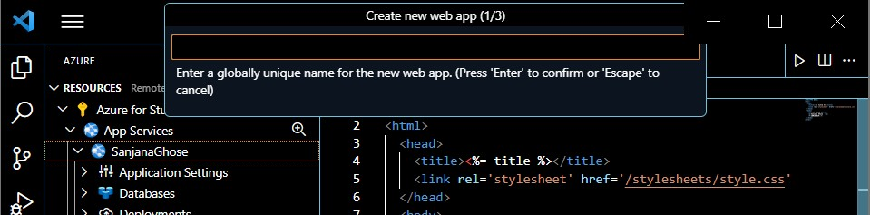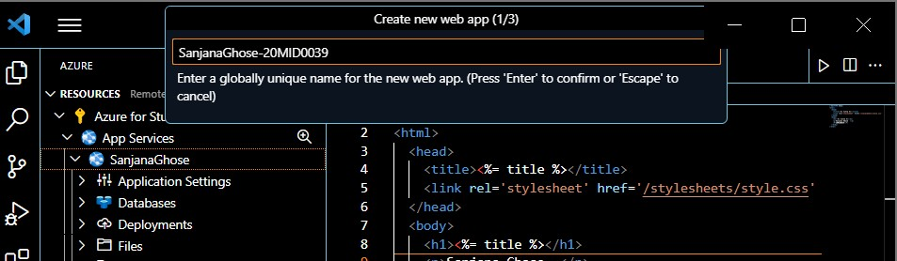

**Step 15:** Select the Node.js version you want. An LTS version is **Node 16 LTS** recommended.

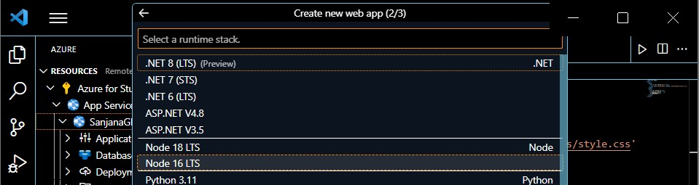

**Step 16:** Select **Create new App Service plan**, then enter a name for the plan (such as *AppServiceQS-plan*), then select **F1 Free** for the pricing tier.

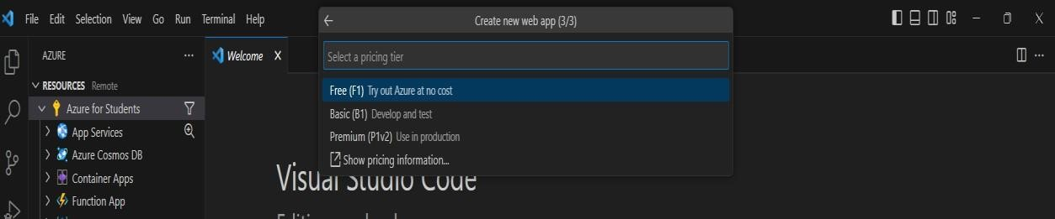

**It will create web app with the mentioned name**

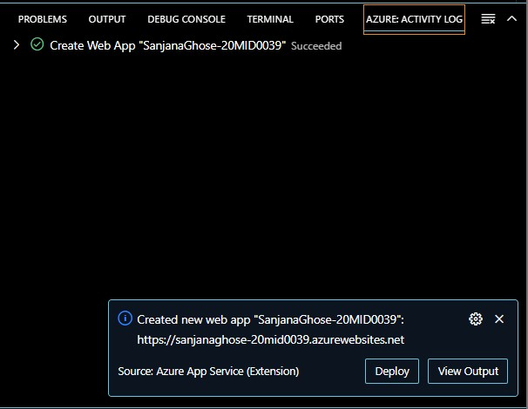

**Step 17: Click on deploy and then** Choose the location

**CLOUD_SANJANA_20MID0039 myExpressApp**

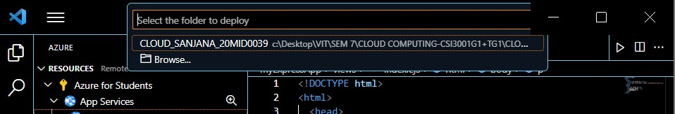

**Step 18:** In the popup **Always deploy the workspace "myExpressApp" to <app-name>"**, select **Yes**. This way, as long as you're in the same workspace, Visual Studio Code deploys to the same App Service app each time.

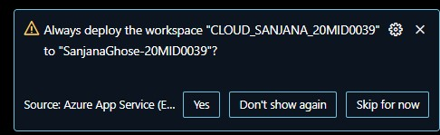

**Step 19:** After successful deployment, click on **Browse Website**

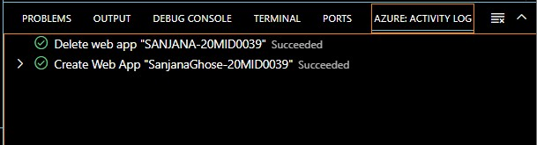

**Step 20:** Finally, your web application will be deployedin the URL with the name you have assigned while creating web application.





**AIM PART 2:**

## Write C programs for the Scheduling algorithms 1)FCFS 2)MAX MIN 3)MIN MIN 1.FCFS

|  |
| --- |
| #include <stdio.h>    // Process structure struct Process { int id; // Process ID int arrival; // Arrival time int burst; // Burst time  };    // Function to perform FCFS scheduling void fcfs(struct Process processes[], int n, int numVMs) { int completionTime[numVMs]; int turnaroundTime[n];    // Initialize completion times for VMs for (int i = 0; i < numVMs; ++i) { completionTime[i] = 0;  }    // Process each job in FCFS order for (int i = 0; i < n; ++i) { int vmIndex = i % numVMs; // Assign jobs to VMs in a cyclic manner  // Calculate start and completion times int startTime = (completionTime[vmIndex] > processes[i].arrival) ?  completionTime[vmIndex] : processes[i].arrival; int endTime = startTime + processes[i].burst;    // Update completion time for the current VM completionTime[vmIndex] = endTime;  // Calculate turnaround time turnaroundTime[i] = endTime - processes[i].arrival;  // Print the schedule printf("Process %d (VM %d): Start Time %d, End Time %d, Turnaround Time  %d\n", processes[i].id, vmIndex + 1, startTime, endTime, turnaroundTime[i]);  }  } int main() {  // Example usage int numProcesses = 5; int numVMs = 2;    // Example processes |
| struct Process processes[] = {  {1, 1, 6},  {2, 3, 4},  {3, 4, 5},  {4, 7, 5},  {5, 9, 7}  };    // Perform FCFS scheduling fcfs(processes, numProcesses, numVMs);  return 0;  } |

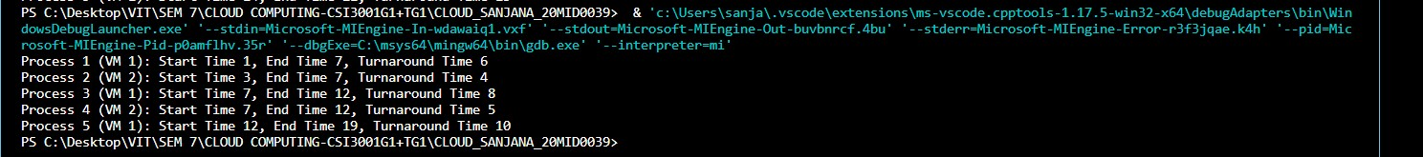

## 2. MAXMIN

|  |
| --- |
| #include <stdio.h>    // Process structure struct Process { int id; // Process ID int arrival; // Arrival time int burst; // Burst time  };    // Function to perform maximum-minimum scheduling void maxMin(struct Process processes[], int n, int numVMs) { int completionTime[numVMs]; int turnaroundTime[n];    // Initialize completion times for VMs for (int i = 0; i < numVMs; ++i) { completionTime[i] = 0;  }    // Process each job in max-min order for (int i = 0; i < n; ++i) {  int minCompletionTime = completionTime[0]; int minVMIndex = 0;    // Find VM with minimum completion time for (int j = 1; j < numVMs; ++j) {  if (completionTime[j] < minCompletionTime) { minCompletionTime = completionTime[j]; |
| minVMIndex = j;  }  }    // Schedule the process on the VM with minimum completion time int startTime = (minCompletionTime > processes[i].arrival) ?  minCompletionTime : processes[i].arrival; int endTime = startTime + processes[i].burst;    // Update completion time for the current VM completionTime[minVMIndex] = endTime;    // Calculate turnaround time turnaroundTime[i] = endTime - processes[i].arrival;  // Print the schedule printf("Process %d (VM %d): Start Time %d, End Time %d, Turnaround Time  %d\n", processes[i].id, minVMIndex + 1, startTime, endTime, turnaroundTime[i]);  }  } int main() {  // Example usage int numProcesses = 5; int numVMs = 2;    // Example processes  struct Process processes[] = {  {1, 0, 6},  {2, 2, 4},  {3, 4, 8},  {4, 6, 5},  {5, 8, 7}  };    // Perform maximum-minimum scheduling maxMin(processes, numProcesses, numVMs);  return 0;  } |

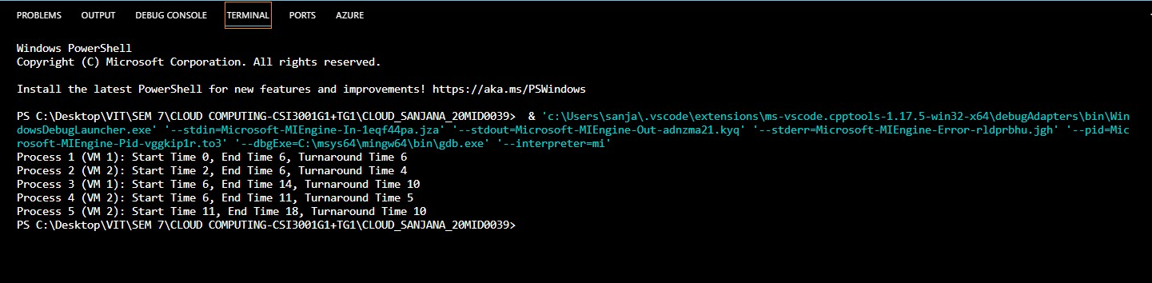

## 3. MINMIN

|  |
| --- |
| #include <stdio.h>    // Process structure struct Process { int id; // Process ID int arrival; // Arrival time int burst; // Burst time  };    // Function to perform minimum-minimum scheduling void minMin(struct Process processes[], int n, int numVMs) { int completionTime[numVMs]; int turnaroundTime[n];    // Initialize completion times for VMs for (int i = 0; i < numVMs; ++i) { completionTime[i] = 0;  }    // Process each job in min-min order for (int i = 0; i < n; ++i) { int minCompletionTime = completionTime[0]; int minVMIndex = 0;    // Find VM with minimum completion time for (int j = 1; j < numVMs; ++j) { if (completionTime[j] < minCompletionTime) { minCompletionTime = completionTime[j]; minVMIndex = j;  }  }    // Schedule the process with the minimum burst time on the VM with minimum completion time int startTime = (minCompletionTime > processes[i].arrival) ?  minCompletionTime : processes[i].arrival; int endTime = startTime + processes[i].burst;    // Update completion time for the current VM completionTime[minVMIndex] = endTime;    // Calculate turnaround time turnaroundTime[i] = endTime - processes[i].arrival;  // Print the schedule printf("Process %d (VM %d): Start Time %d, End Time %d, Turnaround Time  %d\n", processes[i].id, minVMIndex + 1, startTime, endTime, turnaroundTime[i]);  }  } |
| int main() {  // Example usage int numProcesses = 5; int numVMs = 2;    // Example processes  struct Process processes[] = {  {1, 0, 6},  {2, 2, 4},  {3, 4, 8},  {4, 6, 5},  {5, 8, 7}  };    // Perform minimum-minimum scheduling minMin(processes, numProcesses, numVMs);  return 0;  } |

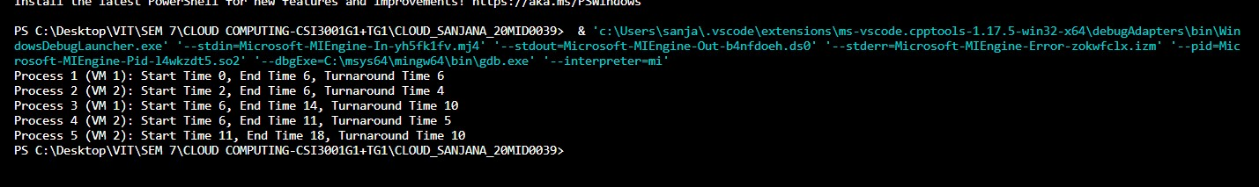

**Experiment 6- IoT hub through Azure and establish a Bi-directional communication (MY accounts credits are over hence from now on ill be using another accounts credits)**

**Aim:**

To build the IoT hub environment in the cloud and deploy Bidirectional Communication with the IoT Hub in the Cloud.

**Procedure:**

# Section I: Creating an IoT hub

**Step 1:** Search for IoT hub and there it is IoT hub for Microsoft. Let's go ahead and create this.

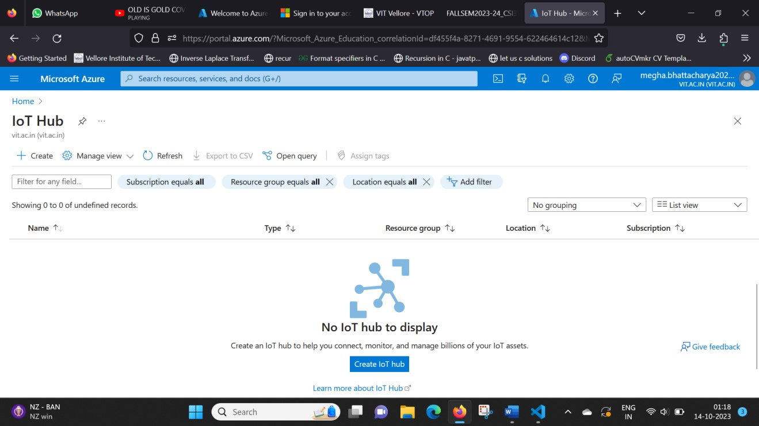

**Step 2:** There are several options we can configure for our new hub. Once you’ve done this, move on to the size and scale options. Here we can configure the pricing and scale tier.

**Step: 2.1:** Create a Resource Group by giving a name in the combination of your number and name with the prefix of rg.

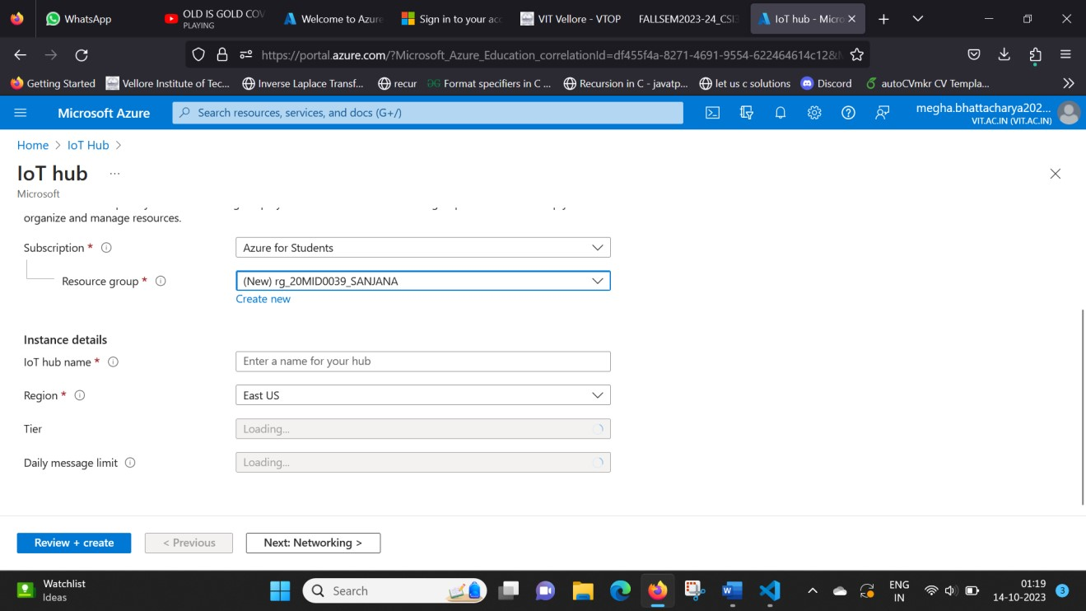

**Step 2.2** Give a name for the IoT hub in the combination of your number and name.

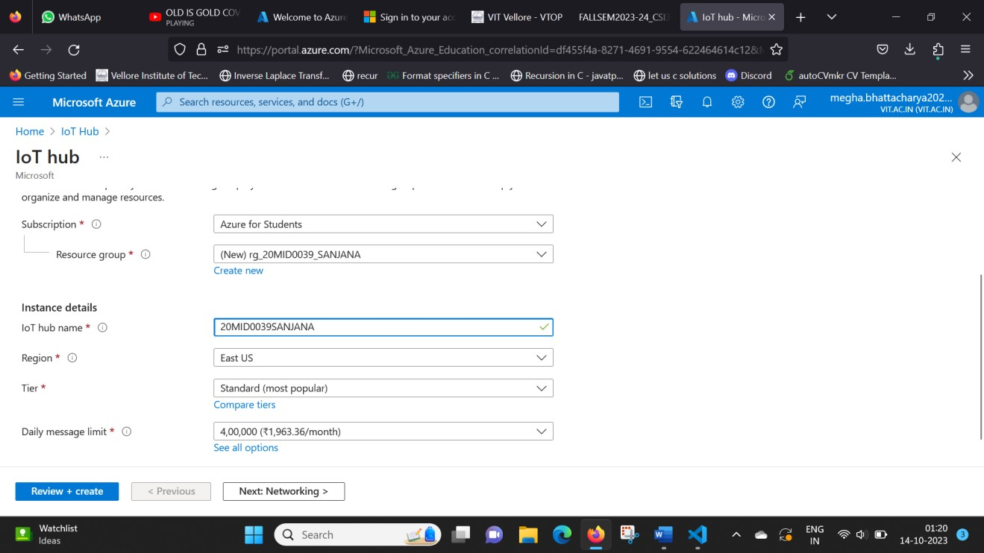

**Step 3** Click on Review + Create. Then you will get a following window. It takes some time to complete the deployment.

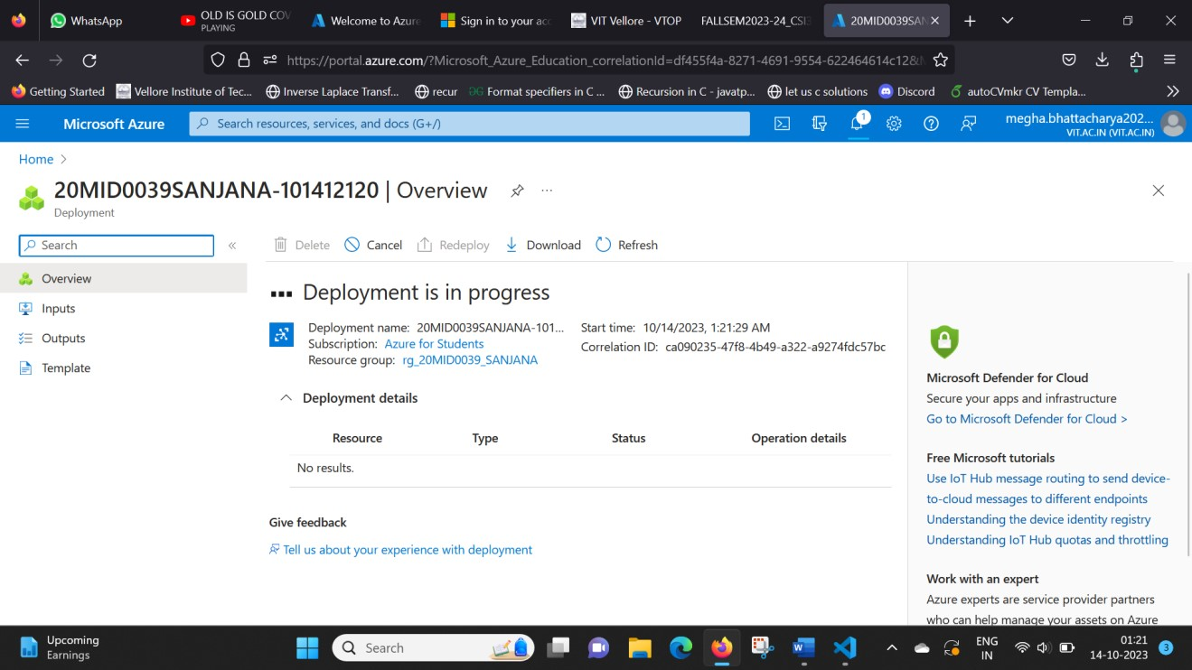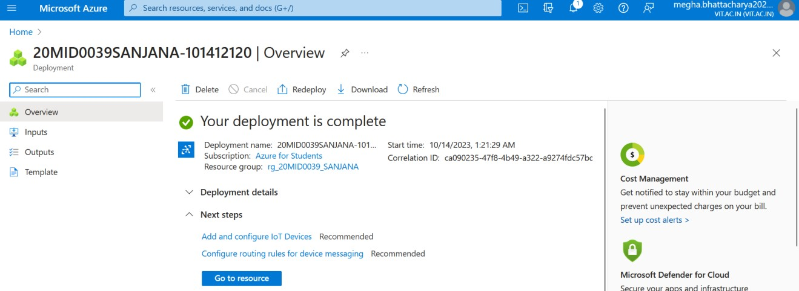

**Step 4:** Click on Go to the resource. The summary view shows us some basic stats about our hub, and if we scroll down, we can see how many messages we've sent, as well as how many devices we have while we're here.

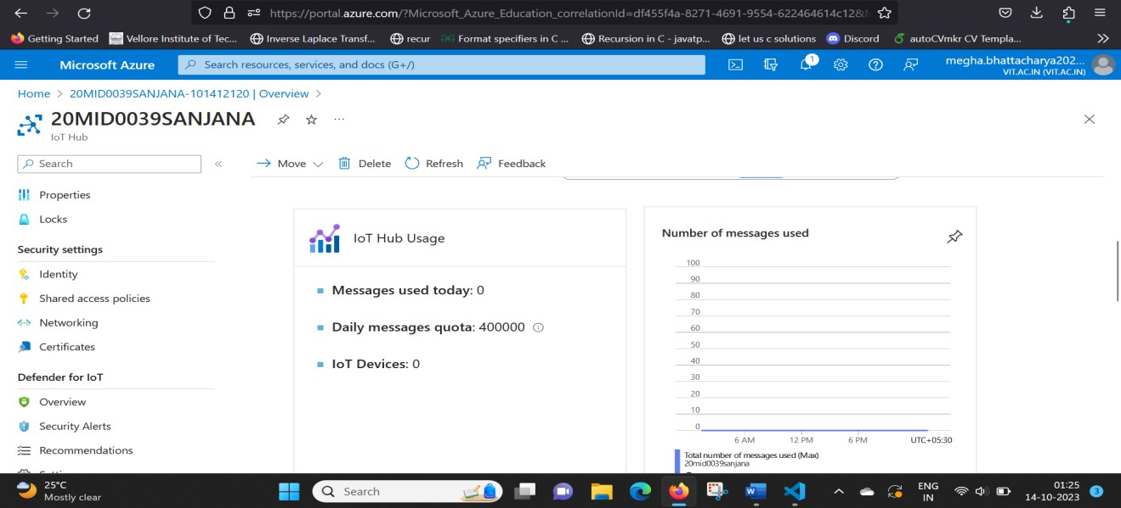

# Section II: Creating a device (VS Code)

**Step 5:** Here we are in VS Code that is already installed with the Azure IoT Hub Toolkit extensions. If not install VS Code and add IoT Hub Toolkit extensions. Access Azure IoT Hub Toolkit through the Command Palette. One way to get to the Command Palette is by going to the View menu and choosing Command

Palette, like this.

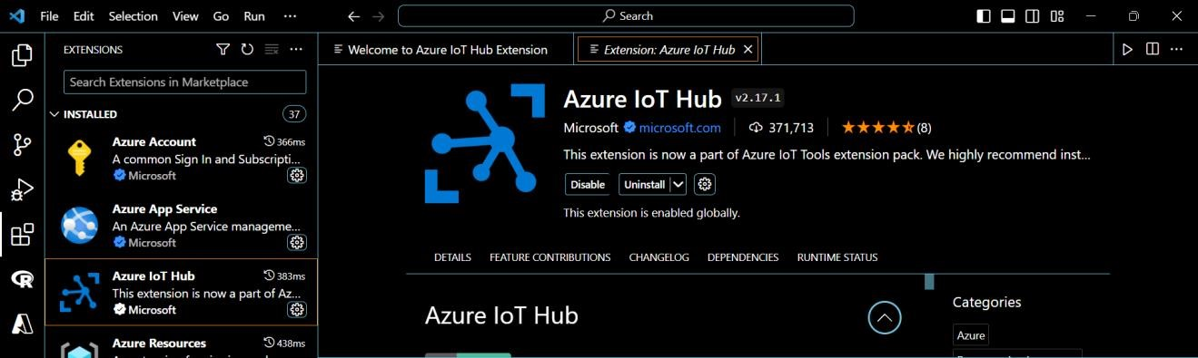

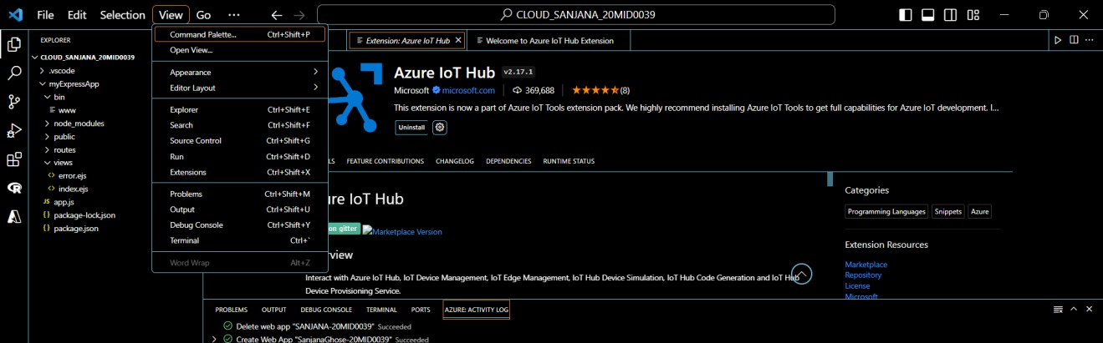

**Step 6:** Type welcome in our Command Palette, then choose to show the Azure IoT Hub welcome page.

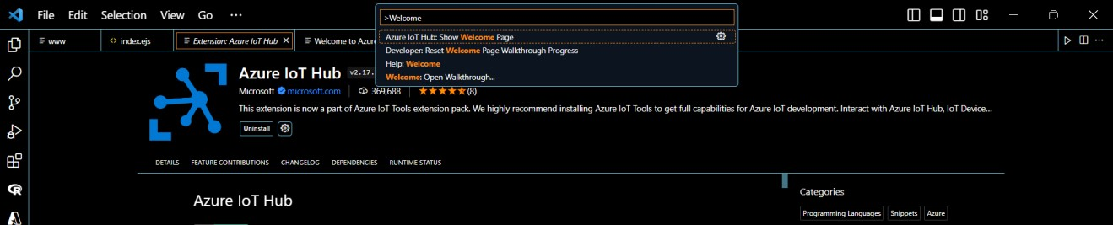

**Step 7:** This welcome page has some links and instructions to help us get started. We already have a hub, so let's choose to select an existing hub.

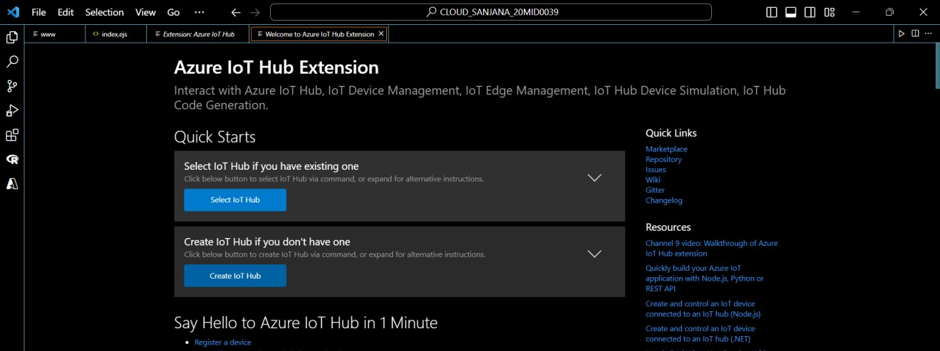

That opens up the command Palette where we can select the subscription to use, and then we can select the hub we want to use.

\

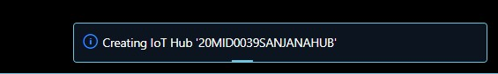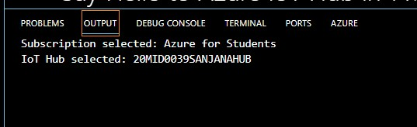

Now that we're connected, we can expand the Azure IoT Hub Devices panel down here, and we can see that we have no devices yet.

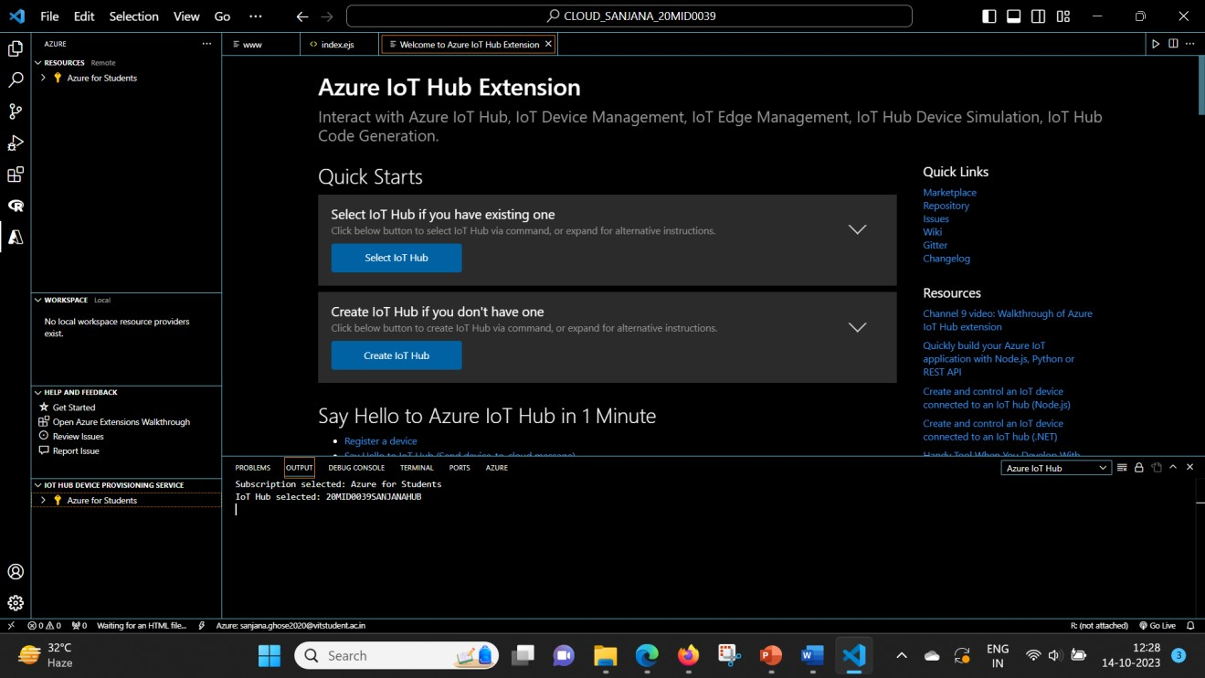

**Step 8:** Click the Action menu, and then choose Create Device or type Azure iot hub create device

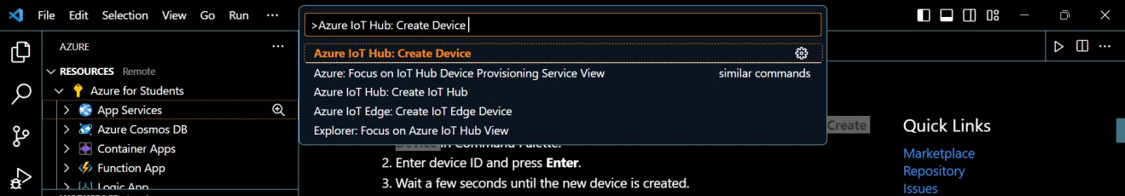

**Step 9:** That will again pop open the Command Palette, this time for us to type a name for our device. Here, the name **sanjanadevice1** is used.



**Step 10:** After successful creation the following message will be displayed in Terminal section.

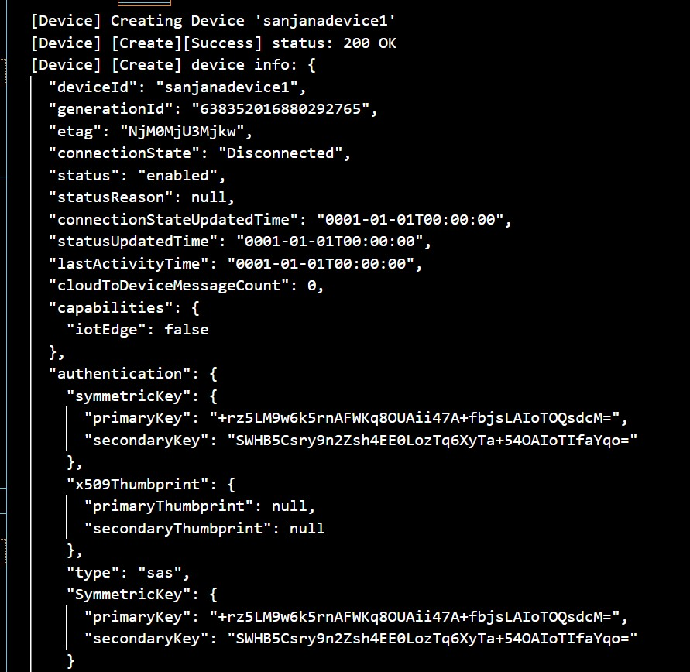

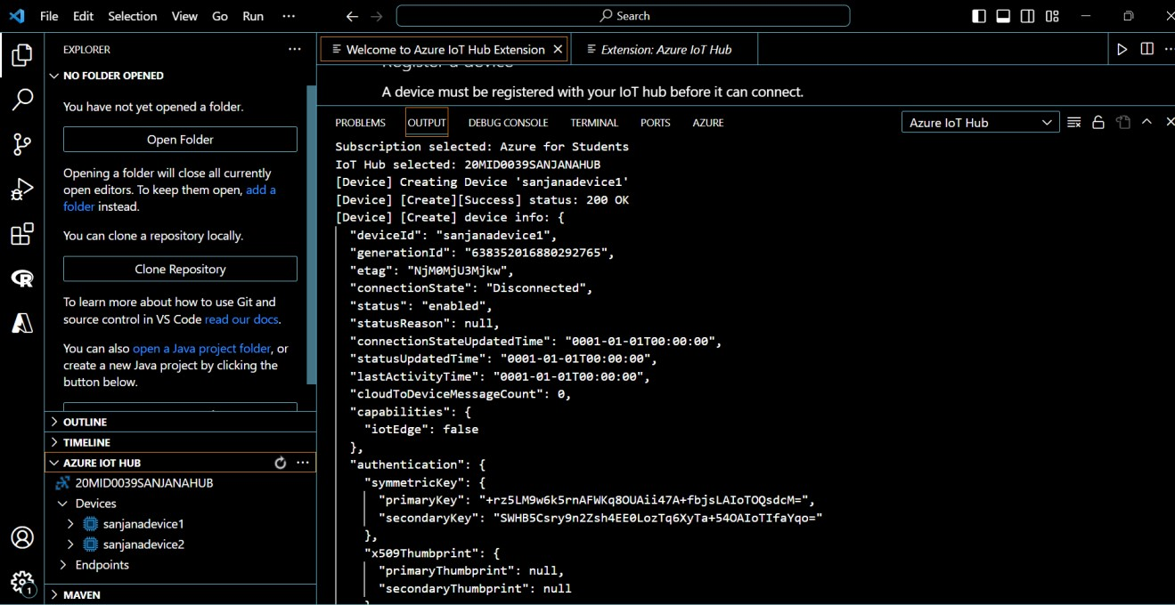

# Section III: Sending a D2C Message (VS Code)

**Note:** *Now that we've created device identities on our hub, we're ready to explore sending and receiving messages, but how are we going to do that without a real device? Well, we actually don't need a real device, because Microsoft has given us tools that allow us to send and receive messages as if we were using a real device.*

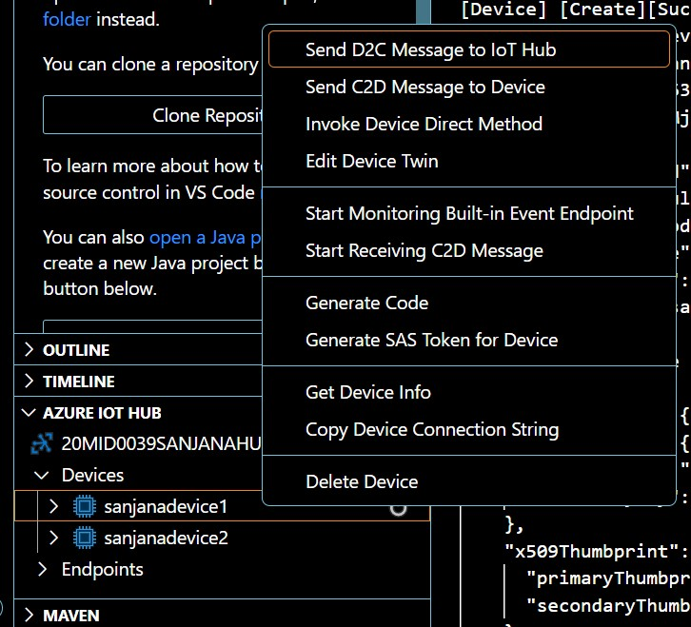

That will open the Command Palette for us to type the message that we want to send. Let's send Hello from VS Code.

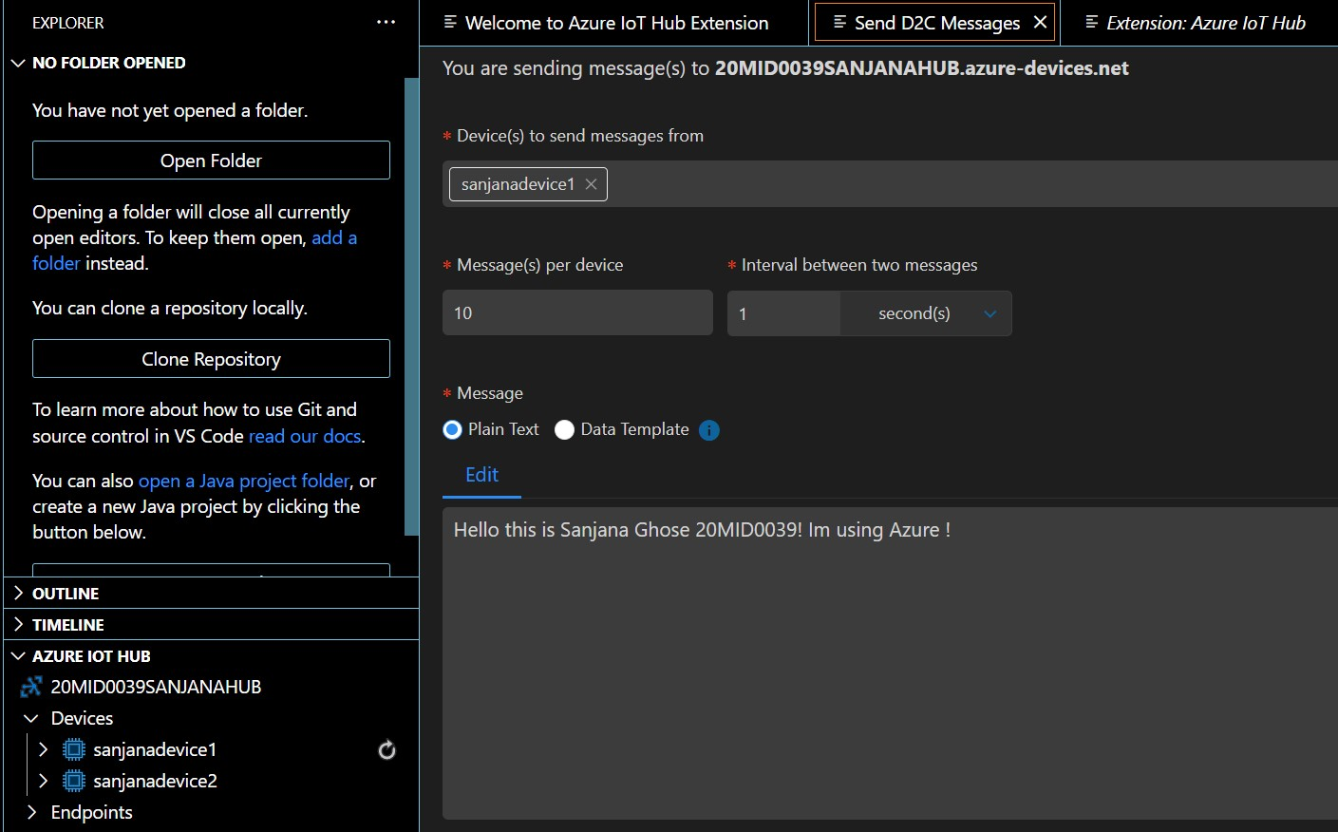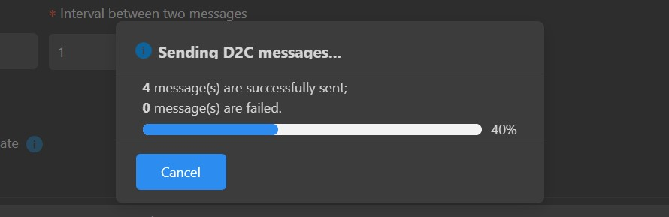

**Step 11:** Well, it looks like it worked, but how can we be sure? We need some way to monitor and see what messages our IoT Hub is actually receiving. Fortunately for us, we can do that right here in VS Code. Let's right-click on our device again, and this time let's choose **Start Monitoring Built-in Event Endpoint**.

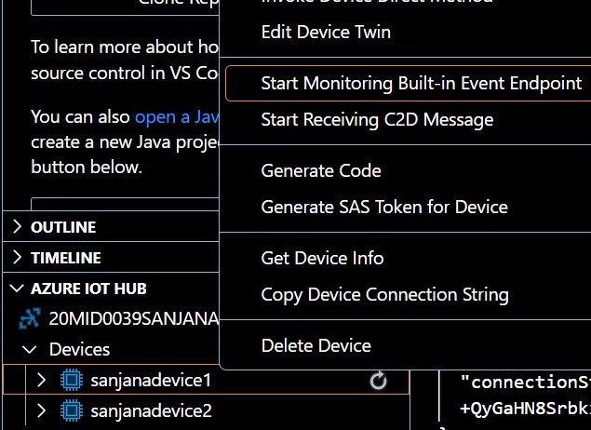

Now let's send another message. Let's give this message a different payload so we can tell the difference between this message and the one we sent before.And look at that, there's our message. It arrived at the hub exactly as we expected.

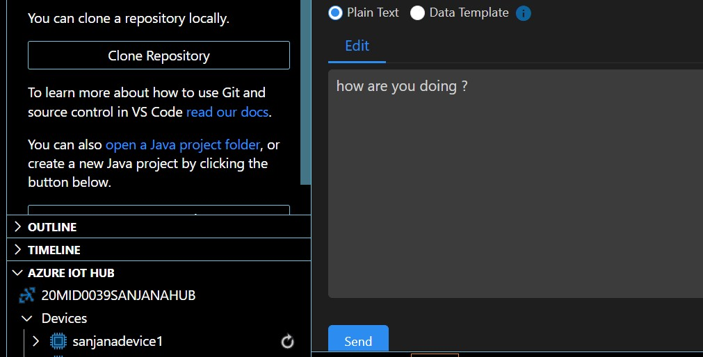

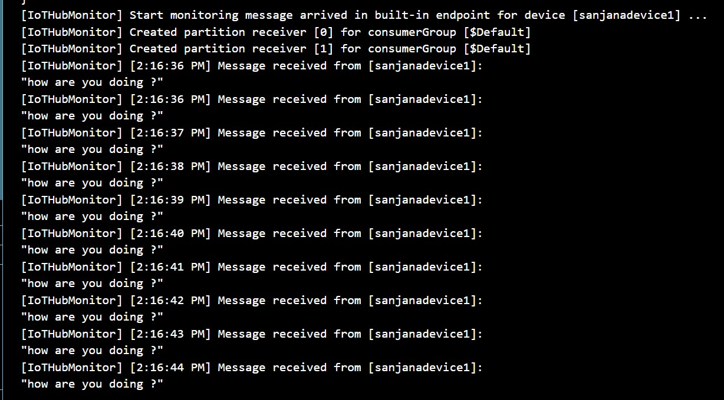

**cdiii Section IV: Sending a C2D Message (VS Code)**

**Step 12:** Right-click the device and choose "Send C2D Message to Device".

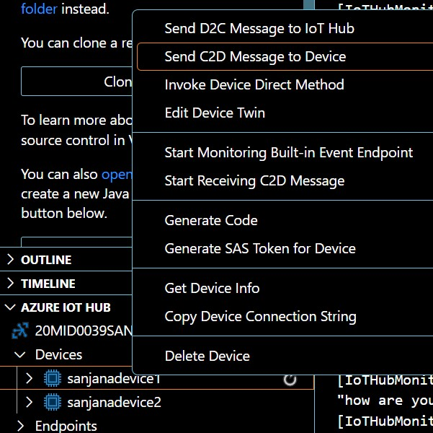

**Step 13:** That opens the Command Palette where we can drop in the value we want to send, and off the message goes. VS Code also gives us the ability to receive that message without the need for a real device.

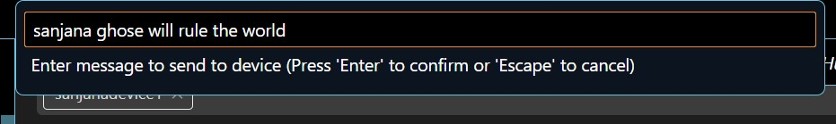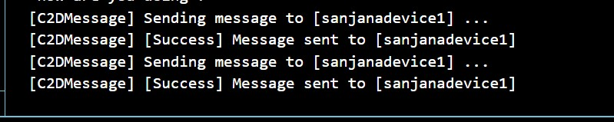

**Step 14:** Right-click on our device again, and this time choose Start Receiving C2D Message.

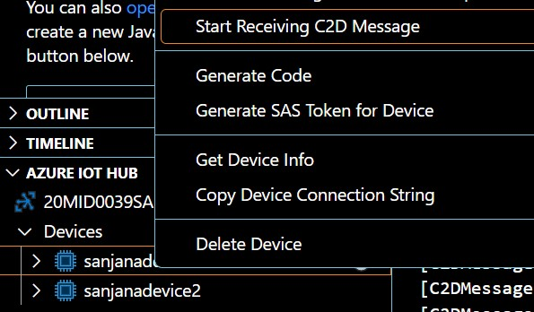

**Step 15:** Send another message. VS Code received the message on behalf of our device from the hub just like a real device would

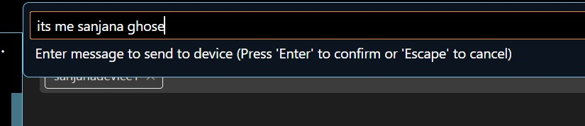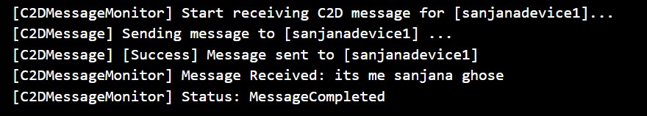

**Step 16:** Go to Azure and open the created IoT Hub. It will show the number of messages used.

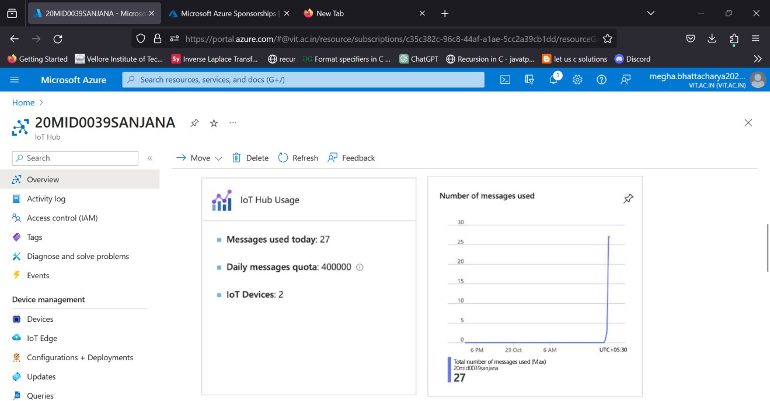

## Name : Sanjana Ghose Reg :20MID0039 AIM: Create an architecture to show the working of the SMTP Email Server

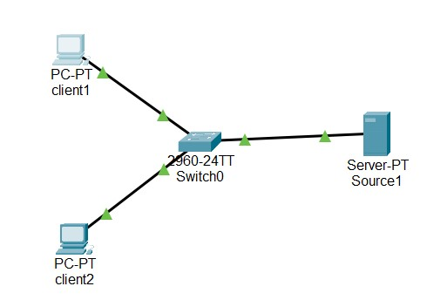

## Step 1: Create 2 PC’s (rename to client 1and 2), one switch and one server, and config the Ip addresses as 192.0.0.1 to 192.0.0.3

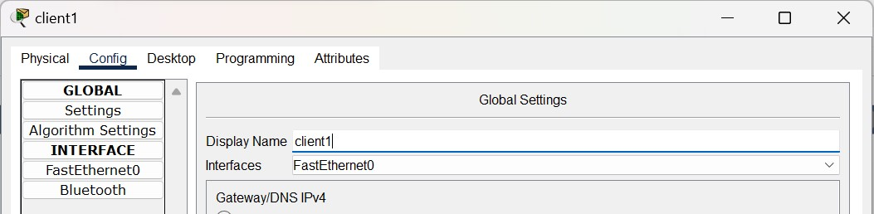

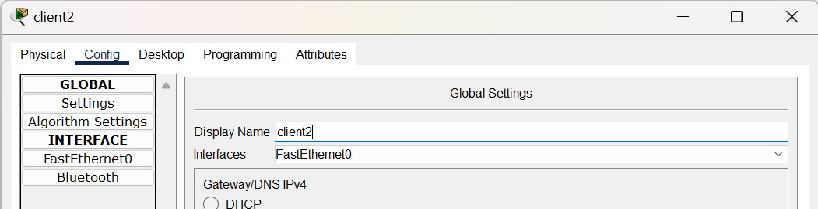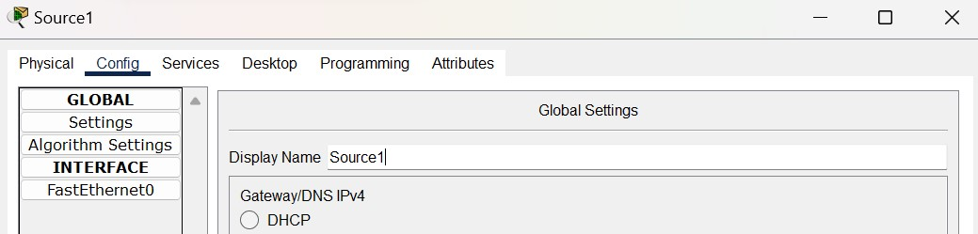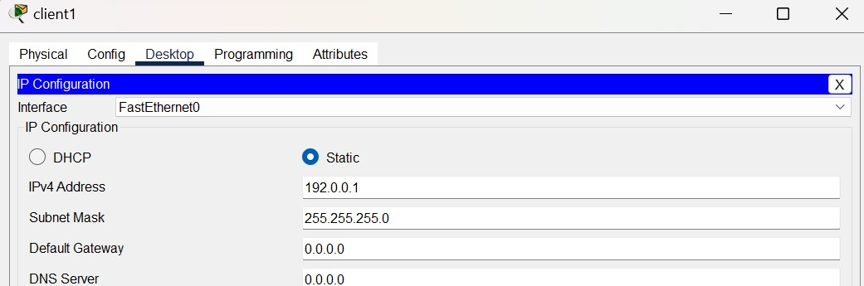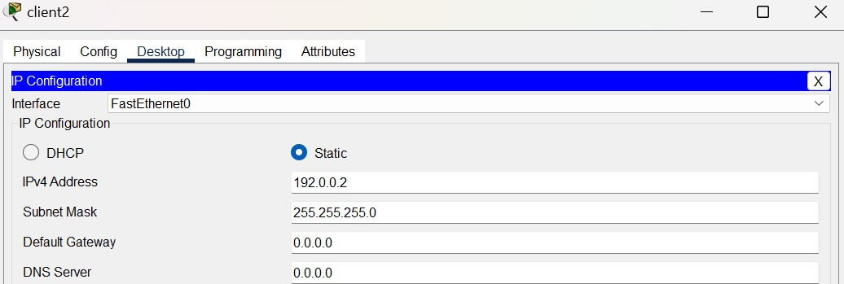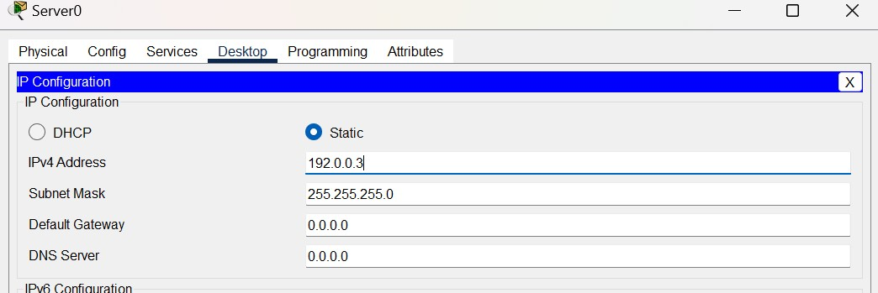

## Step2: Go to Email in Server and set the domain name, user name etc

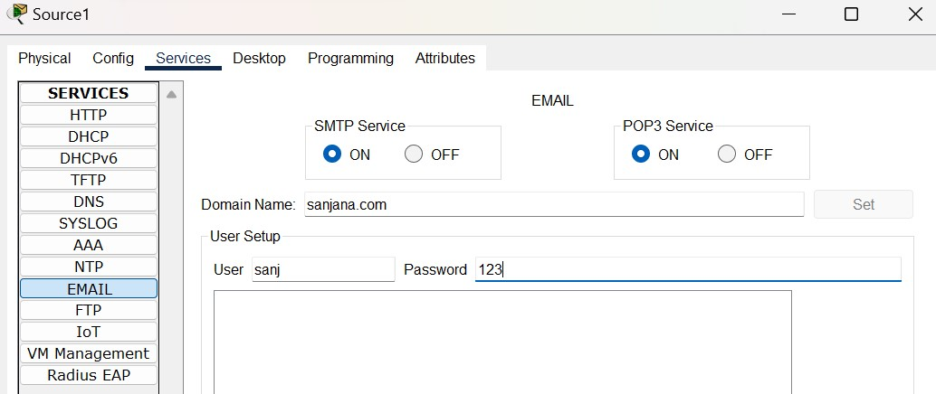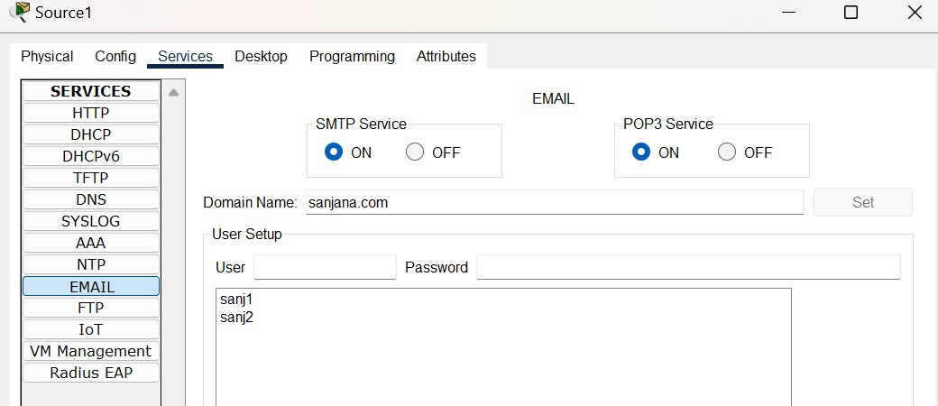

## Step 3: Go to Desktop in each of the clients and configure mail settings as below

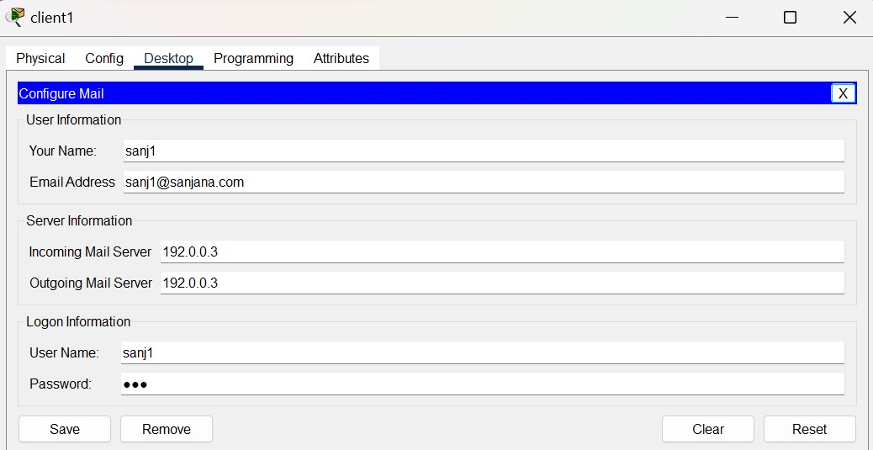

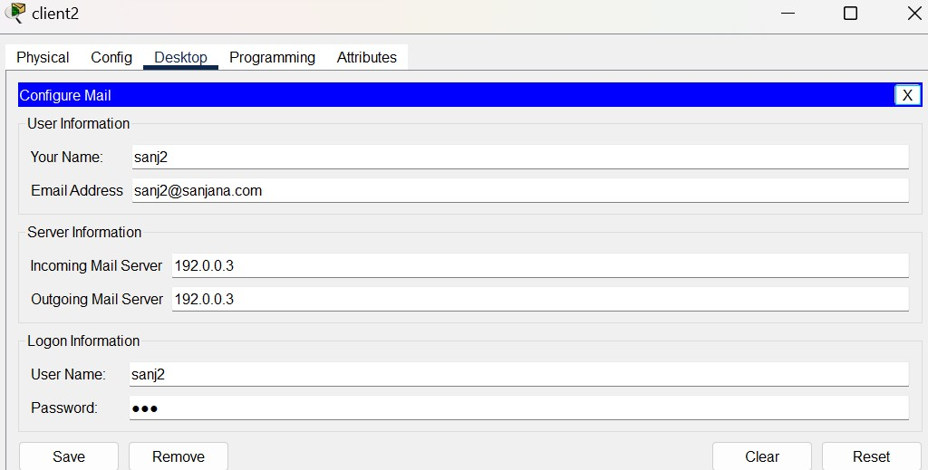

## Step 4: Compose a mail from client 1 and receive it in client 2

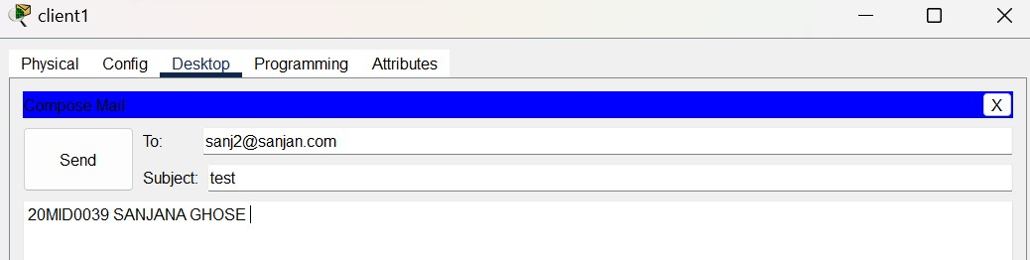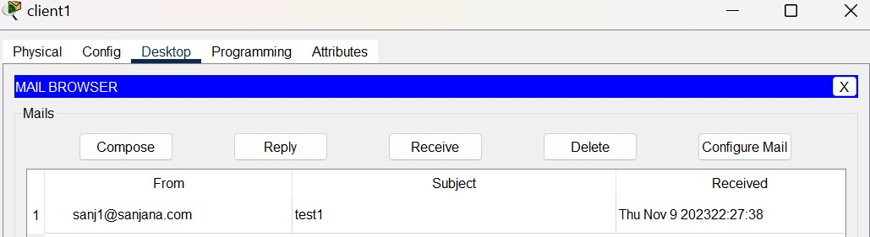



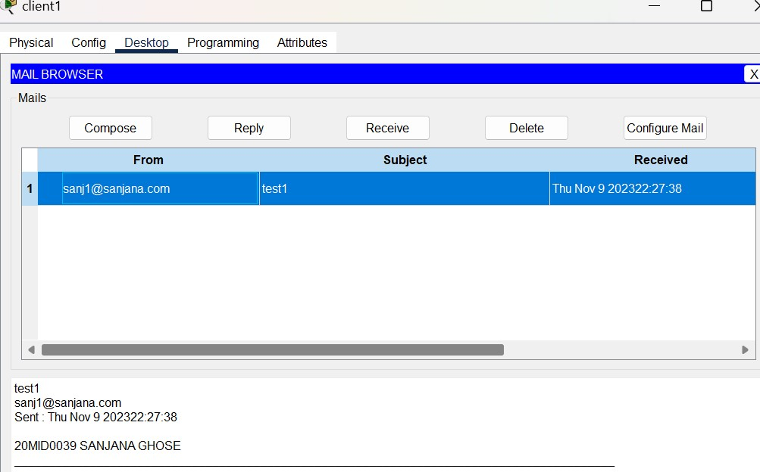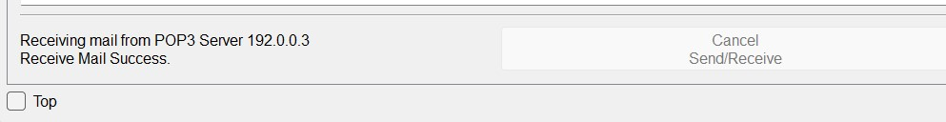

## AIM :Create an architecture to show the working of the DNS Server Make the Architecture Configure the ip address of each device

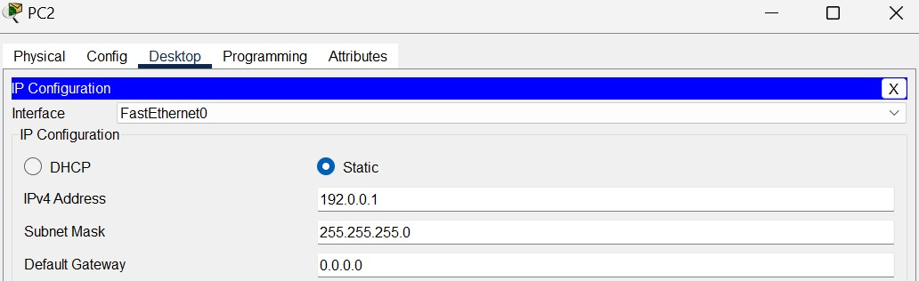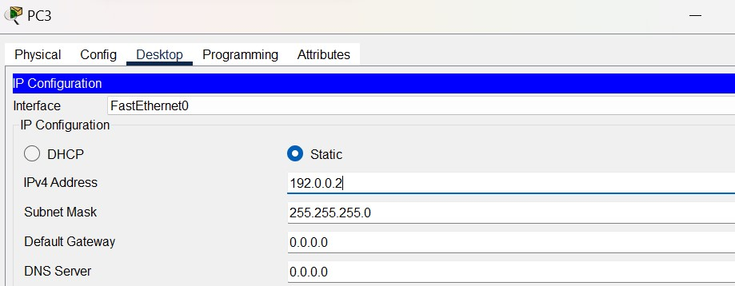

## SET THE IP SERVER CONFIG OF THE SERVER TO 192.0.0.3

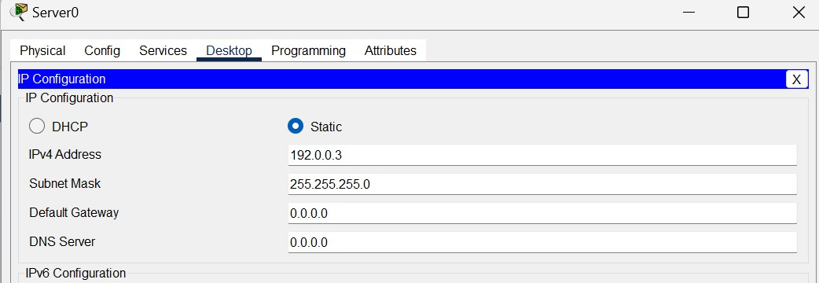

## THEN GO TO SERVICES ->DNS->TURN ON ->GIVE Name(Sanjana)and ip address to servers address(192.0.0.3)

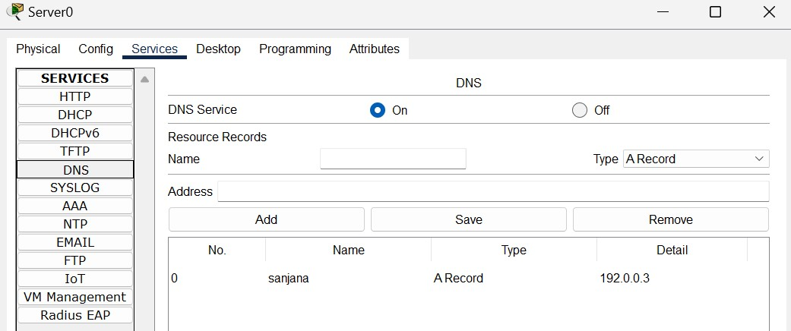

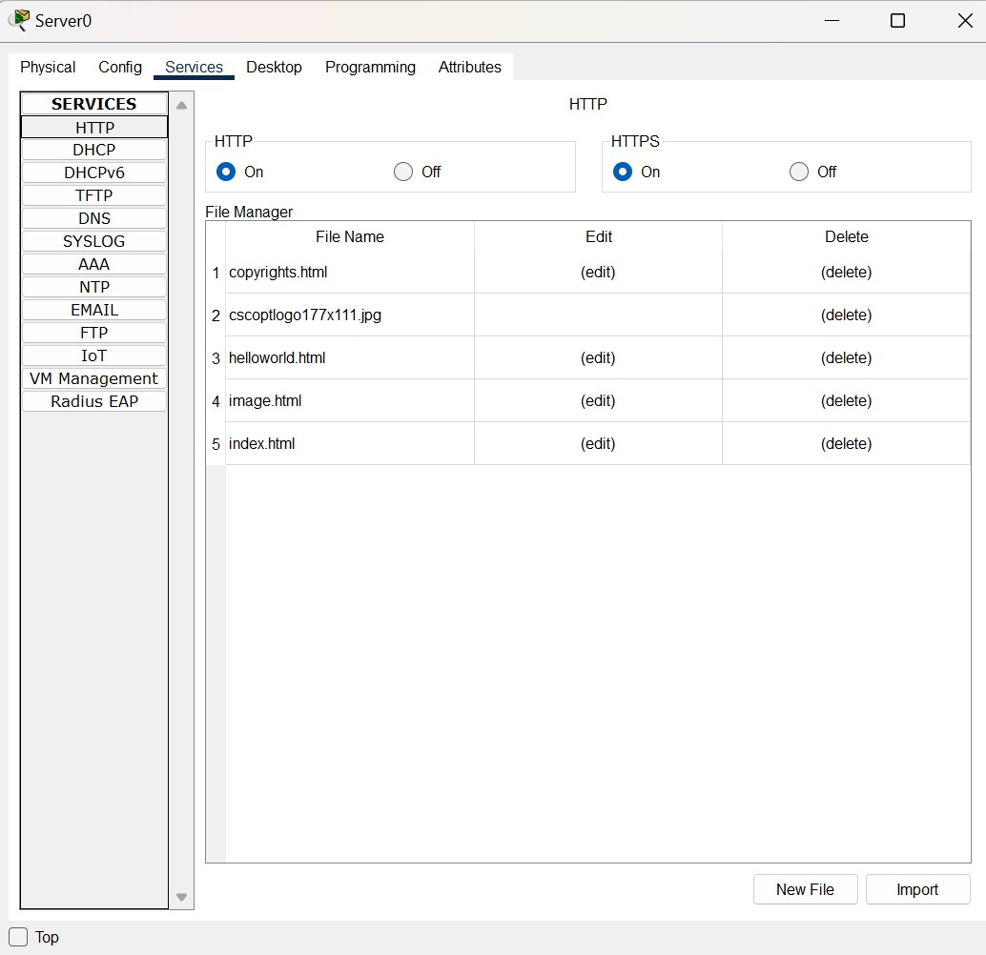

## Click edit-> delete inner part

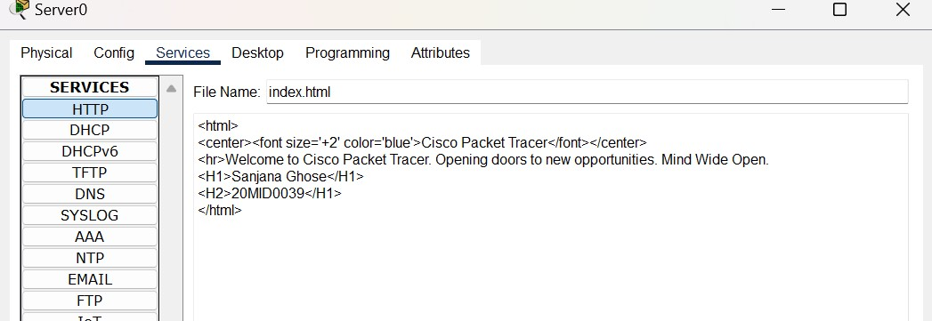

## CHANGE DNS SERVER CONFIG OF EACH PC TO THE SERVERS IP ADDRESS

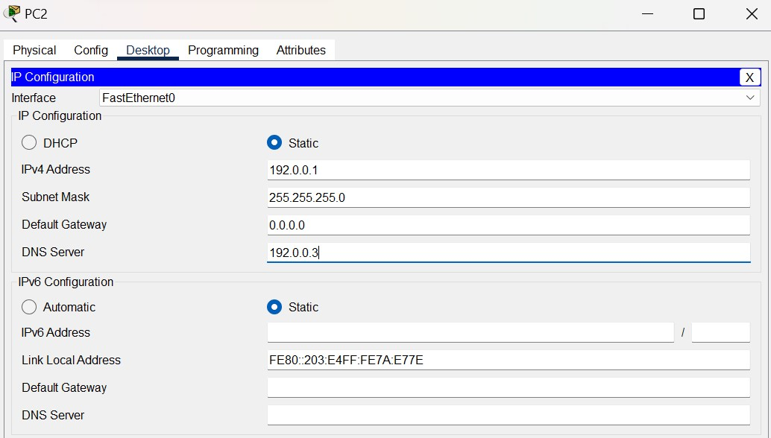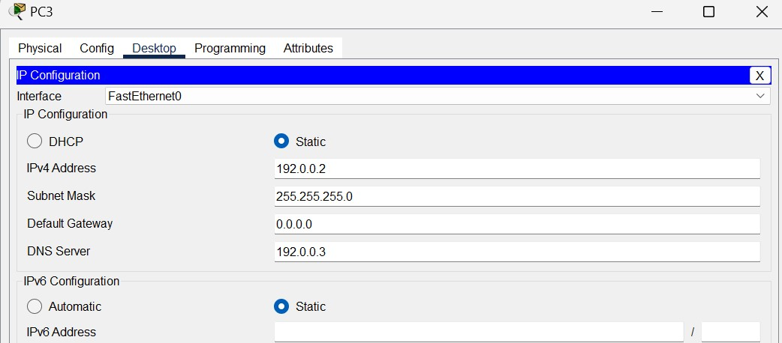

## CLICK ON THE DEVICE ->DESKTOP->WEBROWSER->TYPE IP ADDRESS OF SERVER(192.0.0.3)->GO FROM PC2 WEB BROWSER

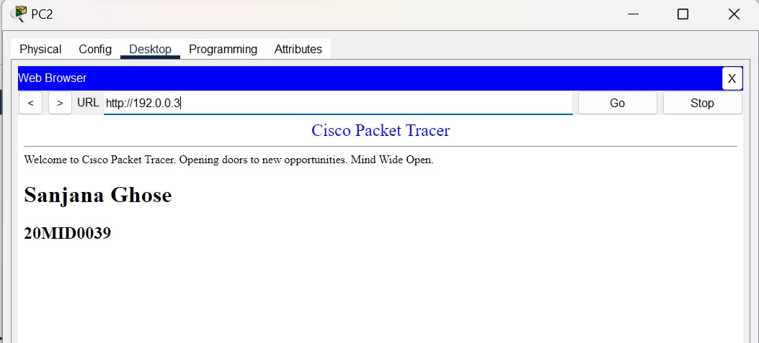

## FROM PC3 WEB BROWSER

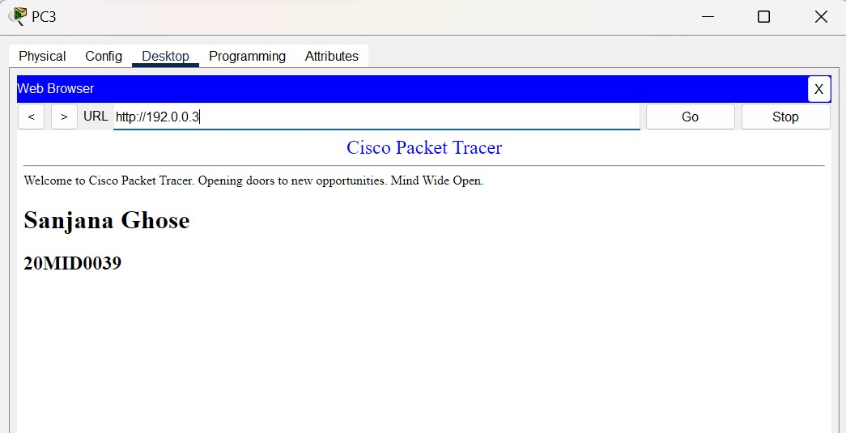

**AIM 2: WORKING OF THE FTP SERVER**

## Add another Server to the network

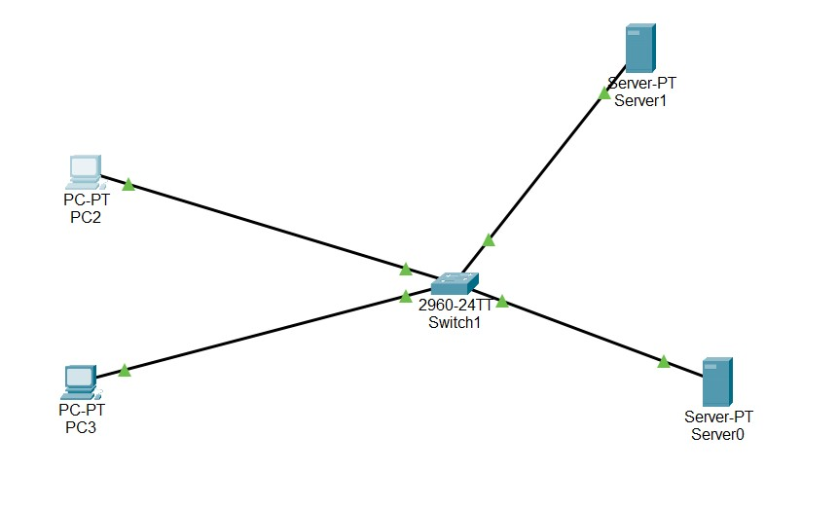

## Create 2 usernames with passwords and enable all permissions and click on add

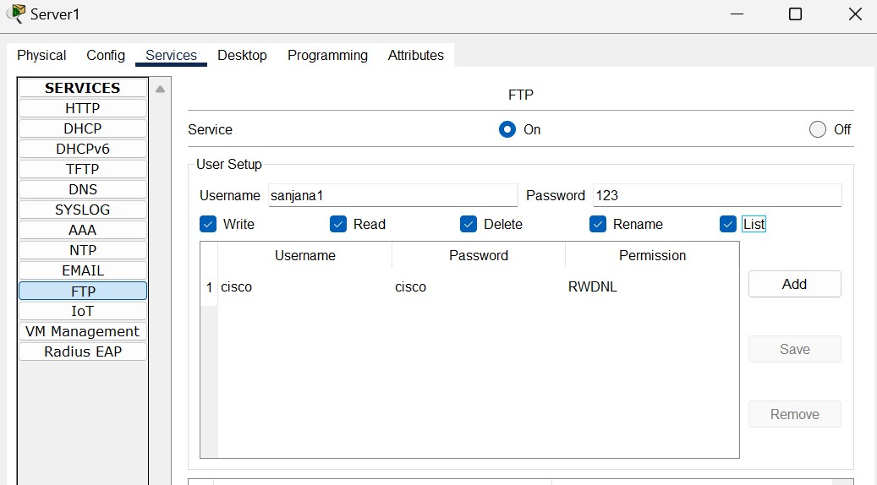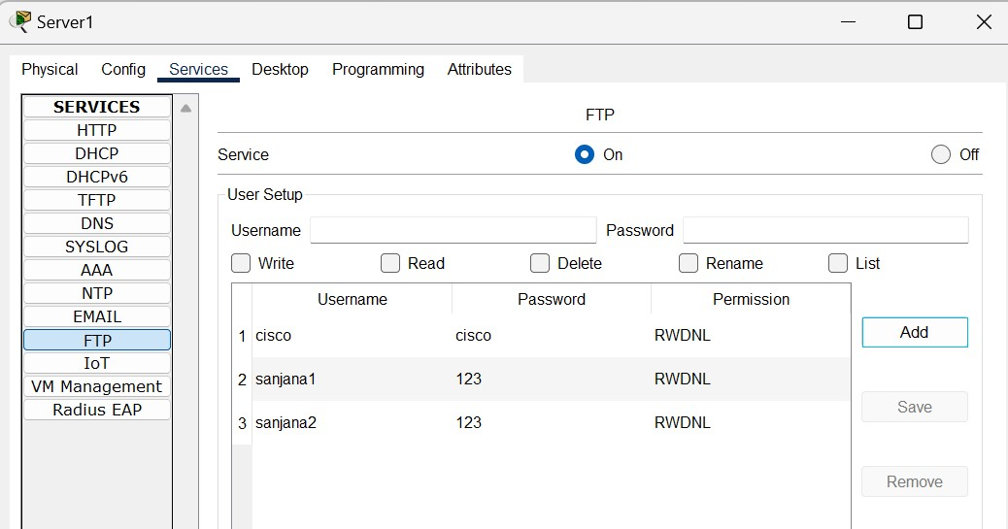

## Set the ip address

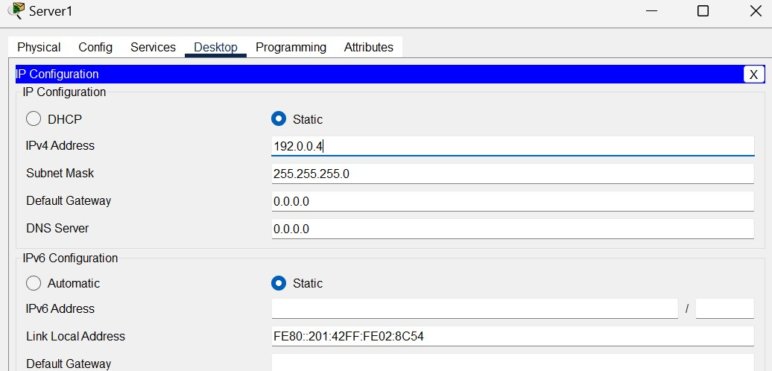

## Type something in the file(text editor)->save with .txt extension

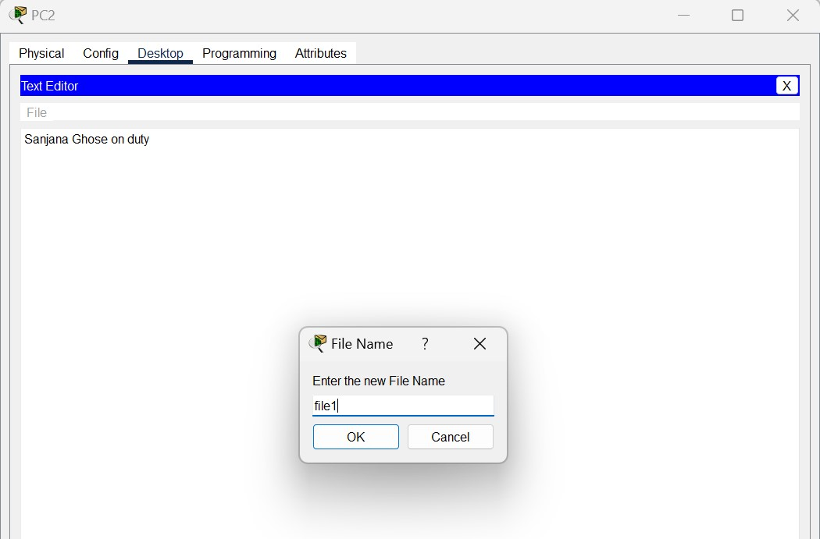

## Go to command promt of the client->ftp 192.0.0.4

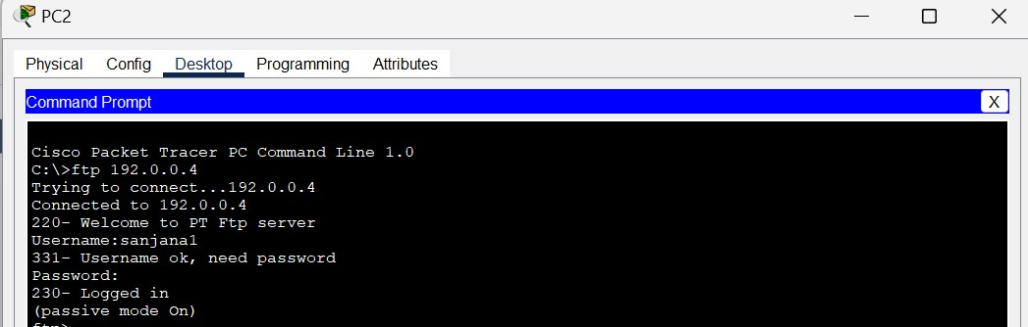

**Transferring from server to client we use “put filename.txt” then “get filename.txt”**

